DWL-G810

Date: April 22, 2004

Product name: | Enhanced 2.4 GHz Ethernet to Wireless Bridge
Product Group & Type:
Revision: | A1
Available:
Picture: | 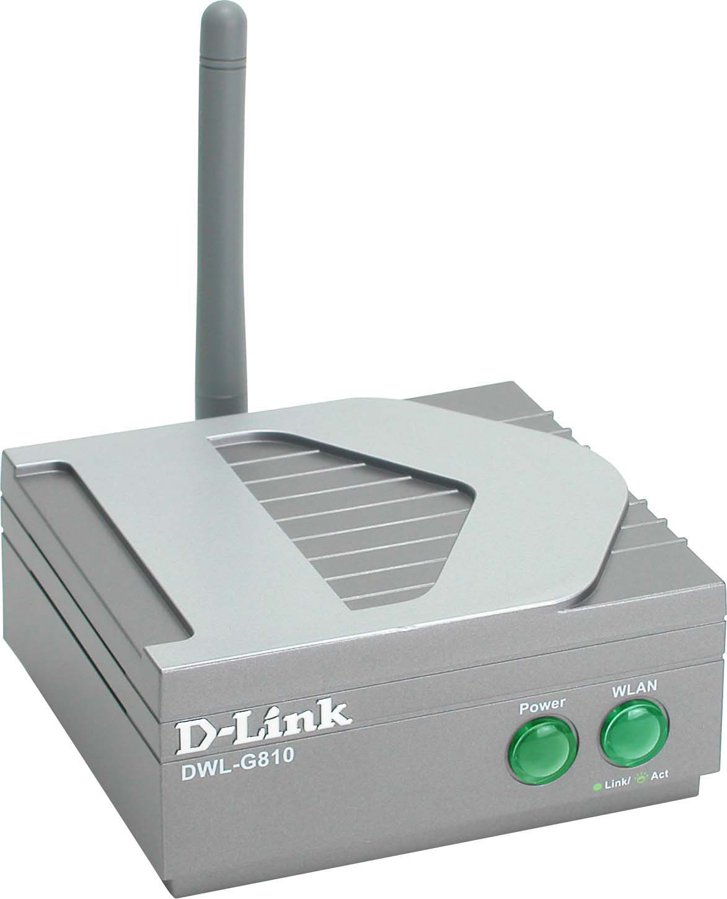
Why Sell This Product: | - Additional choice for game players & printer/Ethernet device wireless connection: With this new 802.11g DWL-G810 and and the current 802.11b+ DWL-810+, now you have 2 clear-cut products with 2 different speeds to offer to your customers.  - Expand your wireless 802.11g AirPlusXtremeG product range.  Selling Points  - 108Mbps Super G high speed.  - Award-winning product ("Pick-O-the-Crop" March 2004 award).
Keyfeatures: | - Easy, fast wireless connection for Ethernet devices  - 802.11g wireless LAN standard  - 2.4GHz frequency band  - Up to 108Mbps Turbo mode data transfer rate  - 10/100Mbps Ethernet port with auto MDI/MDIX connection to network device  - WPA security, 64/128/152-bit WEP data encryption  - Ad-hoc and infrastructure modes  - Web-based configuration
Technical Details: | Standards  - IEEE 802.11g wireless LAN  - IEEE 802.3/802.3u 10BASE-T/100BASE-TX Fast Ethernet  Adapter Type  Fast Ethernet to 802.11g Wireless LAN  Device Port  10/100BASE-TX Ethernet port with auto MDI/MDIX  Media Access Control Protocol  CSMA/CA with ACK  Network Architecture Types  Supports ad-hoc and infrastructure modes  Operating Mode  Wireless client  Network Transfer Rate/Modulation Technique  - 802.11b:  11Mbps, 5.5Mbps: CCK  2Mbps: DQPSK  1Mbps: DBPSK  - 802.11g:  108Mbps Super G, 54Mbps, 48Mbps, 36Mbps, 24Mbps, 18Mbps,  12Mbps, 9Mbps, 6Mbps: OFDM (Orthogonal Frequency Division  Multiplexing)  Frequency Range  2.4 to 2.4835 GHz  Operating Channels  - 1 to 11 channels (FCC)  - 1 to 13 channels (ETSI)  Antenna  2dBi Gain detachable external dipole antenna (reverse SMA connector)  Operating Range *  - Indoor: up to 100 meters (328 feet)  - Outdoor: up to 400 meters (1,312 feet)  * Environmental factors may adversely affect range  Transmitter Output Power  15dBm (32mW) +/- 2dB  Data Security  - WEP 64/128/152-bit data encryption (user-selectable)  - Wi-Fi TM Protected Access with TKIP, MIC, IV Expansion,  Shared Key Authentication  Configuration/Management  Web-based (Internet Explorer v.6 or later, Netscape Navigator v.7 or later, or other Java-enabled browsers)  Physical & Environmental  Diagnostic LEDs  - Power  - WLAN  DC Input  5V 2.0A  Power Supply  Through external power adapter  Dimensions  90 (L) x 82 (W) x 40 (H) mm  Weight  153 grams  Operating Temperature  0 to 55 °C  Storage Temperature  -20 to 75 °C  Humidity  Up to 95% non-condensing  Emission Certification  - FCC Class B  - CE Class B  Safety Certification  UL
EMI/EMC Report | ☑FCC No. ☑ CE No. ◻ VCCI No.  ◻ CTR-21 No. ☑ C-Tick No. ACN052202838 ◻ A-Tick No.  ◻ FDA No. ◻ R&TTE No. ◻ BSMI No.  ◻ Others
Safety | ◻ TUV No. ◻ UL No. ◻ CSA No.  ◻ Others
Packaging Style | ◻ Clamshell ◻ White Box ☑ Gift Box ◻ Bulk ◻ Others
Packaging Contents: | DWL-G810 Ethernet  Wireless Bridge  MasterCD(Manual,QIG)QIG, Ethernet Cable, AC power Adapter
UPC Code:
  BDWLG810..B1 | 790069262043
  CDWLG810..B1 | 790069262043
  DWLG810ANAB1 | 790069262647
  DWLG810ENAB1 | 790069262654
  DWLG810BEUB1 | 790069262661
  DWLG810EEUB1 | 790069262678
  DWLG810NEUB1 | 790069262685
  DWLG810CN.B1 | 790069262692
  TDWLG810..B1 | 790069262715
Units Per Carton: | 5
Cartons Per Pallet: | Air: 60, Sea: 90
Dimensions and Weight: | Box: 275 x 208 x 66 mm, 0.81 kg  Carton: 440 x 360 x 290 mm, 5.15 kg  Pallet: (by Air) 1200 x 1100 x 1600 mm, 260 kg  (by Sea) 1200 x 1100 x 2000 mm, 380 kg  INTRASTAT weight: kg (Box)  Packing material weight (Box):  - Paper: kg  - Plastic: kg  - Mixed: kg

