DWL-P50

Date: September 14, 2004

Product name: | Power over Ethernet Adapter
Product Group & Type:
Revision: | A1
Available:
Picture: | 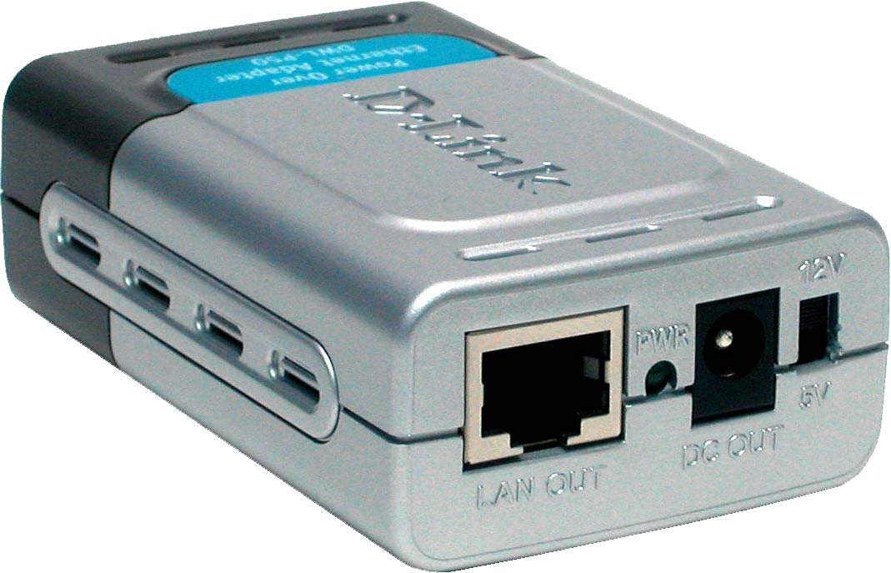
Why Sell This Product: | - This PoE adapter is designed to work with 802.3af PoE switches like the DES-1316. It supports both 5VDC and 12VDC, and is great for selling with the DES-1316 and D-Link wireless AP and Internet cameras.  Selling Points  - Dual 5VDC/12VDC support.  - Guaranteed operation with D-Link products.
Key Features: | - Provides DC power over existing Category 5 cable to wireless LAN device  - Cuts costs and provides convenience  - Transforms incoming AC power into low-voltage DC power  - Protects wireless LAN device from possible power-surges  - Supports both 5VDC and 12VDC power (selectable through a slide switch)  - Very compact size, lightweight  - Complete plug-and-play installation, no configuration setting or installation tool required  - No software required, O.S.-independent
Technical Details: | Output Voltage  - Input: 48VDC, 400mA  - Output: 5VDC (11.5 watts) or 12VDC (12 watts) (slide switch selectable)  Ethernet Cable  - TIA/EIA 568 Cat. 5  - Connector: RJ-45  Diagnostic LED  Power  Dimensions  80.9 x 52 x 28 mm (adapter only)  Weight  80 grams (adapter only)  Operating Temperature  0 to 40 ℃ (32 to 104 ℃)  Storage Temperature  -40 to 70 ℃ (-40 to 158 ℃)  Operating Humidity  10% to 80% RH  Storage Humidity  5% to 90% RH  EMI  - FCC Part 15 Class B  - CE Class B  Safety  - UL  - TUV  Box Includes  - DWL-P50 PoE adapter  - Quick Installation Guide  - Ethernet cable  - DC power cable with female power connectors
EMI/EMC Report | ☑FCC No. NEI-FCCE-1-04E0565 ☑ CE No. NEI-EMC-1-04E0565 ☑ VCCI No. NEI-VC-1-04E0565  ◻ CTR-21 No. ◻ C-Tick No. ◻ A-Tick No.  ◻ FDA No. ◻ R&TTE No. ◻ BSMI No.  ◻ Others
Safety | ◻ TUV No. ☑ CUL No. ◻ CSA No.  ◻ Others
Packaging Style | ◻ Clamshell ☑ White Box with D-Link logo ◻ Gift Box ◻ Bulk ◻ Others
Packaging Contents: | - One DWL-P50 PoE adapter  - One RJ-45 Ethernet Cable  - One Female-to-Female power connector  - One hard copy QIG
UPC Code:
  BWLP50….A1 | 790069 271694
  EWLP50….A1 | 790069 271038
  IWLP50….A1 | 790069 271021
  NWLP50….A1 | 790069 271014
  TWLP50….A1 | 790069 271007
Units Per Carton: | 40
Cartons Per Pallet: | Air: 18 (for USA), 24 (for WW), Sea: 30
Dimensions and Weight: | Box: 232 x 165 x 33 mm, 0.3 kg  Carton: 495 x 400 x 300 mm, 12.22 kg  Pallet: (by Air) 1020 x 1220 x 1260 mm, 321 kg (for USA)  1200 x 1100 x 1650 mm, 423 kg (for WW)  (by Sea) 1020 x 1220 x 2020 mm, 525 kg (for USA)  1200 x 1100 x 2010 mm, 525 kg (for WW)  INTRASTAT weight: kg (Box)  Packing material weight (Box):  - Paper: 0.136 kg  - Plastic: 0.071 kg  - Mixed: 0.151 kg

