
ProductAnnouncement

Date: May, 28,2002
To: All Locations

Subject: New Product Release for D-Link DMC-1002;
SNMP Module for Chassis-Based Media Converter

MODEL NO.: DMC-1002
PART NO.: DMC1002...A1
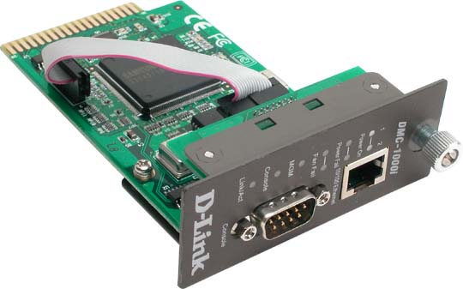

About DMC-1002
The Management Module provides the brain of the Chassis-Based Media Converter systems ( DMC-1000 ) for D-Link’s media converter family. It features a 32-bit, high performance RISC microprocessor executing a real-time operating system. It supports the SNMP Manage, WEB-base management and console management.
During normal operation, the DMC-1002 polls all converters and power supplies within its domain each fresh time which is software configurable, collecting status and module information as well as setting required parameters. It reports its collected status via the SNMP, WEB, Telnet or Console.
The DMC-1002 is password protected to prevent unauthorized access. New module software updates to the DMC-1002 can be downloaded during normal network operation via web or tftp.

Product Feature
- One 10/100Mbps Fast Ethernet port and one RS-232 port for management
- Web-based management via Http on the out-of-band 10/100M Fast Ethernet port
- Real-time display the link, speed, duplex status of media converters.
- Menu-driven terminal management through the console port or Telnet
- Support SNMP v.1 Agent Management with MIB-2 and enterprise MIBs
- Support cold start, warm start, authentication fail, power fail, fan fail, module insertion, module pullout, port link down and port link up traps
- Firmware update download as well as configuration setting upload and download through tftp or web update
- Support factory reset and remote software reboot
- Support redundant backup of media converter
- Remote set the configurations of Smart Media Converter module, like LLCF enable, LLR enable, port enable, auto-negotiation enable, etc.

Technical Specification
Management | Specifications
Chassis  Converter Module  Alarms  Active Control | Protocols  Diagnostic LEDs  - Power1, 2,  - Power Fail 1, 2  - Fan Fail 1, 2  - MGM  - Console  - Link / Activity  Dimensions (W x D x H)  - 120 x 88 x 25 mm  Temperature  - Operating: 0 ~ 40 ºC  - Storage: -25 ~ 70 ºC  Humidity  - Operating: 10% ~ 90% RH  - Storage: 5% ~ 90% RH  Emission  - FCC Class B  - CE mark Class B  - VCCI-B
  - Part Number | - Revision
  - Description | - Chassis Reset
  - Power status
  - Link Status | - Converter Type
  - Slot Occupied | - Part Number
  - Revision
  - Cold Start | - Warm Start
  - Link Up | - Link Down
  - Authentication Failure | - Power Supply On/Off
  - Power Supply Inserted | - Power Supply Removed
  - Module Insertion | - Module Removal
  - Module Unknown | - Module Failure
  - Link Loss Carry Forward | - Link Loss Return
  - Module Name | - IP address
  - Reset Module | - Redundant Backup
  - Download software via tftp / http
  - Subnet Mask
  - Default Gateway
  - Telnet to Console Commands
  - IP | - UDP
  - SNMP | - TCP
  - TFTP | - ARP
  - ICMP | - HTTP

Box Includes
- One DMC-1002 SNMP Module
- RS-232 Cable
- User’s guide

Ordering Information
DMC-1002 SNMP Module for Chassis-Based Media Converter

Ordering Price
Please refer to the Price Book from BBU

Lead Time:
About three weeks per order

