

Product Announcement

Taipei, December 2001

New Product
DMC-300M DMC-300SC DMC-515SC DMC-530SC DMC-560SC DMC-810SC DMC-810SC
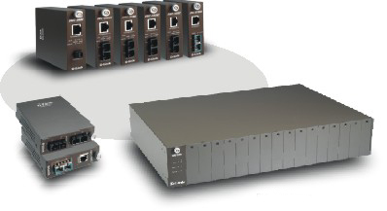

DMC-615SC
DMC-700SC

DMC-1000

To all OBUs:

We are pleased to announce the release of the following new products:

Media Converter Modules
DMC-300M Fast Ethernet Twisted-pair to Fast Ethernet Multi-mode Fiber (2km, MT-RJ) Media Converter Module
DMC-300SC Fast Ethernet Twisted-pair to Fast Ethernet Multi-mode Fiber (2km, SC) Media Converter Module
DMC-515SC Fast Ethernet Twisted-pair to Fast Ethernet Single-mode Fiber (15km, SC) Media Converter Module
DMC-530SC Fast Ethernet Twisted-pair to Fast Ethernet Single-mode Fiber (30km, SC) Media Converter Module
DMC-560SC Fast Ethernet Twisted-pair to Fast Ethernet Single-mode Fiber (60km, SC) Media Converter Module
DMC-615SC Fast Ethernet Multi-mode Fiber (2km SC) to Fast Ethernet Single-mode Fiber (15km, SC) Media Converter Module
DMC-700SC 1000BASE-T Gigabit Twisted-pair to 1000BASE-SX Gigabit Fiber Multi-mode Fiber (2km, SC) Media Converter Module
DMC-700SC 1000BASE-T Gigabit Twisted-pair to 1000BASE-LX Gigabit Fiber Single-mode Fiber (15km, SC) Media Converter Module

Chassis
DMC-1000 Chassis for the above listed Media Converter Modules
These are brand-new chassis-based media converters. All converters can be used as stand-alone devices, or be installed in a DMC-1000 chassis. As stand-alone devices, these converters have their own metal case housing and AC power adapters. When installed in the chassis, the metal case should be removed, and the PC board inside will be slid into the slots of the chassis.

The chassis can be installed in the computer room's equipment rack, and is intended for big installation sites.

These media converters thus provide the flexibility of installation. Also, we're offering
more choices of media conversion for users to select. Remember we have recently phased out many of the older media converter products, such as the DFE-856, DFE-857, DFE-858. So these should be better replacements for you to sell.

Product Availability: Immediately

Price List: Please refer to your latest Price.

Your Contact Windows:
North America: Robert Lin
Europe: Jacob Luo
D-Link International: Lilian Tseng
China, Taiwan : Jack Tseng

We enclose the following materials for your study and application use:

- Datasheet: 1

We're looking forward to your favorable response to this new product.

Best Regards,

Marketing Department
D-Link Taipei

