
Product Announcement

Taipei, July 2002

New Product
DMC-1002 Chassis-based Media Converters' Management Module
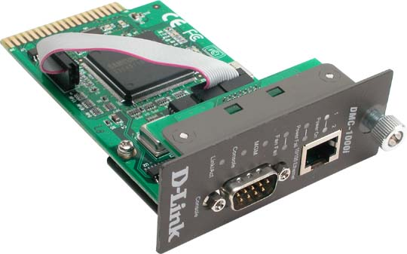
To all OBUs:

The DMC-1000 series Chassis-based Media Converters now have a Management module. This module is an option, and can be installed in the DMC-1000 chassis. It SNMP and http Web standards-based. This option is in addition to the redundant power supply option (announced earlier) that is also available to
the DMC-1000 series.

Product Availability: Immediately

Price List: Please refer to your latest Price Book.
Your Contact Windows:
North America: Robert Lin
Europe: Jacob Luo
D-Link International: Lilian Tseng
China, Taiwan: Jack Tseng

We enclose the following materials for your study and application use:

- Datasheet: 1

We're looking forward to your favorable response to this new product.

Best Regards,

Marketing Department
D-Link Taipei

