
ProductAnnouncement

Date: December, 25,2001
To: All Locations

Subject: New Product Release for D-Link DMC-1001;
Redundant Power Supply of Chassis-Based Media Converter

MODEL NO.: DMC-1001
PART NO.: DMC1001...A1
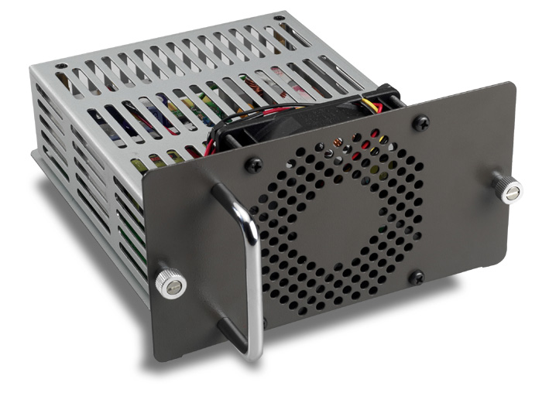

About DMC-1001
When the chassis is equipped with two DMC-1001 power supplies, both power supplies are switched on and share the current load. In case that one of them should fail, the other will instantaneously take 100% of the load without any loss. Similarly, if one power supply is removed from servicing, it can be switched off and removed while the chassis continues functioning.

Product Feature
- Efficiency: The efficiency is higher than 70% by measured at nominal line and rated load.
- Protection: Over voltage protection; short circuit protection.
- Power sharing and redundancy.
- Fan failure Signal: The power supply will provide a predictive fan failure signal that detects a failure based on reduced fan RPM.

Technical Specification

Power Supply
Input Voltage: | 85VAC(60Hz)/264VAC(50Hz) label: 110V-240V
Output Voltage: | +12V
Power Consumption | 150 watts. (max.)
Dimension | 185 x 160 x 85 mm
Temperature | Operating: 0°~40° C,  Storage: -10°~50° C
Humidity | Operating: 10% ~ 90%,  Storage: 5% ~ 90%
Overload Protection | All outputs protected from short circuit condition, automatic recovery
Emissions | FCC Class B, CE Mark Class B, VCCI Class B
Safty Standard | UL 1950CSA  CSA 22.2 No.234

Box Includes
- One DMC-1001 Redundant Power Supply
- User’s guide

Ordering Information
DMC-1001 Redundant Power Supply of Chassis-Based Media Converter

Ordering Price
Please refer to the Price Book from BBU

Lead Time:
About three weeks per order

