DMC-1580SC

Date: December 4, 2003

Product name: | 10/100Basse-TX to 100Base-FX Smart Media Converter
Product Group & Type: | Media Converter
Revision: | A1
Available:
Picture: | 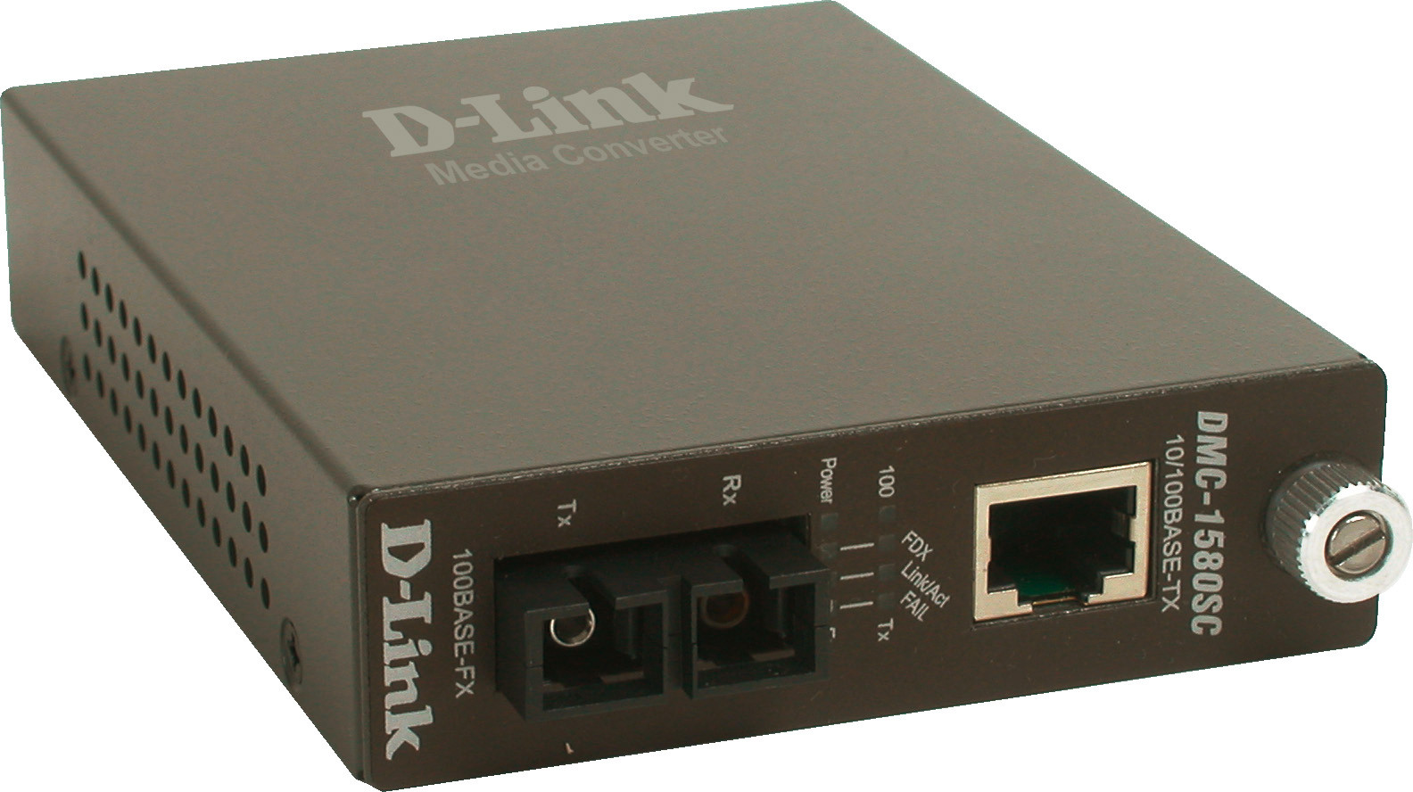
Why Sell This Product: | - Additional media converter supporting longer fiber cable distance (up to 80 km).  - Additional module for DMC-1000 chassis-based media converter.  - Complete solution for SI: this product is targeted at system integrators, for special cases to meet special requirements.
Keyfeatures: | - One-channel media conversion between 10/100BASE-TX and 100BASE-FX  - Supports single-mode fiber using SC connector  - Auto-negotiation of speed and duplex mode on 100BASE-TX port  - Supports link pass through  - Supports Auto MDI/MDIX on 100BASE-TX port  - Sliding switch for configuring fixed half/full duplex modes  - Sliding switch for setting to Forced mode or Auto-negotiation  - Sliding switch for setting the speed  - Sliding switch for setting the LLCF, LLR function  - Store-and-forward mechanism  - Back-pressure & IEEE 802.3x compliant flow control  - Full wire-speed forwarding rate  - Front panel status LEDs  - Can be used as a stand-alone device or installed in a chassis  - Hot-swappable when used with chassis  - Manageable through Intelligent Chassis System
Technical Details: | LED Indicators  - Power  - Speed (for twisted-pair port)  - Full Duplex/Collision (for twisted-pair and fiber ports)  - LINK/ACT (for twisted-pair and fiber ports)  - Fail (for twisted-pair and fiber ports)  Power Input  - 7.5V 1.5A  - Through external power adapter  Power Consumption  7.2 watts max.  Dimensions  120 x 88 x 25 mm  Weight  305 grams  Operation Temperature  0 - 40 °C  Storage Temperature  -25 - 70 °C  Humidity  10 - 90% non-condensing  Emission (EMI)  - FCC Class B  - VCCI Class B  - CE Class B
EMI/EMC Report | ☑FCC No. ☑ CE No. ☑ VCCI No.  ◻ CTR-21 No. ◻ C-Tick No. ◻ A-Tick No.  ◻ FDA No. ◻ R&TTE No. ◻ BSMI No.  ◻ Others
Safety | ◻ TUV No. ◻ UL No. ◻ CSA No.  ◻ Others
Packaging Style | ◻ Clamshell ☑ White Box ☑ Gift Box ◻ Bulk ◻ Others
Packaging Contents: | DMC-1580SC, One AC power cord, User’s Manual, Quick Installation
UPC Code: | 790069 264764/A, 790069 264711/B, 790069 264788/E, 790069 264795/N, 790069 264801, 790069 264818/TW,
Units Per Carton: | 10
Cartons Per Pallet: | Air: 33, Sea: 44
Dimensions and Weight: | Box: 270 x 205 x 65 mm, 1.1 kg  Carton: 366 x 287 x 442 mm, 12 kg  Pallet: (by Air) 1200 x 1100 x 1500 mm, 396 kg  (by Sea) 1200 x 1100 x 1950 mm, 528 kg  INTRASTAT weight: kg (Box)  Packing material weight (Box):  - Paper: kg  - Plastic: kg  - Mixed: kg

