DMC-1910

Date: 4/11/ 2005

Product name: | 1000Base-TX to 1000Base-LX Single Fiber Media converter
Revision: | A1
Available: | 4/29/2005
Picture: | 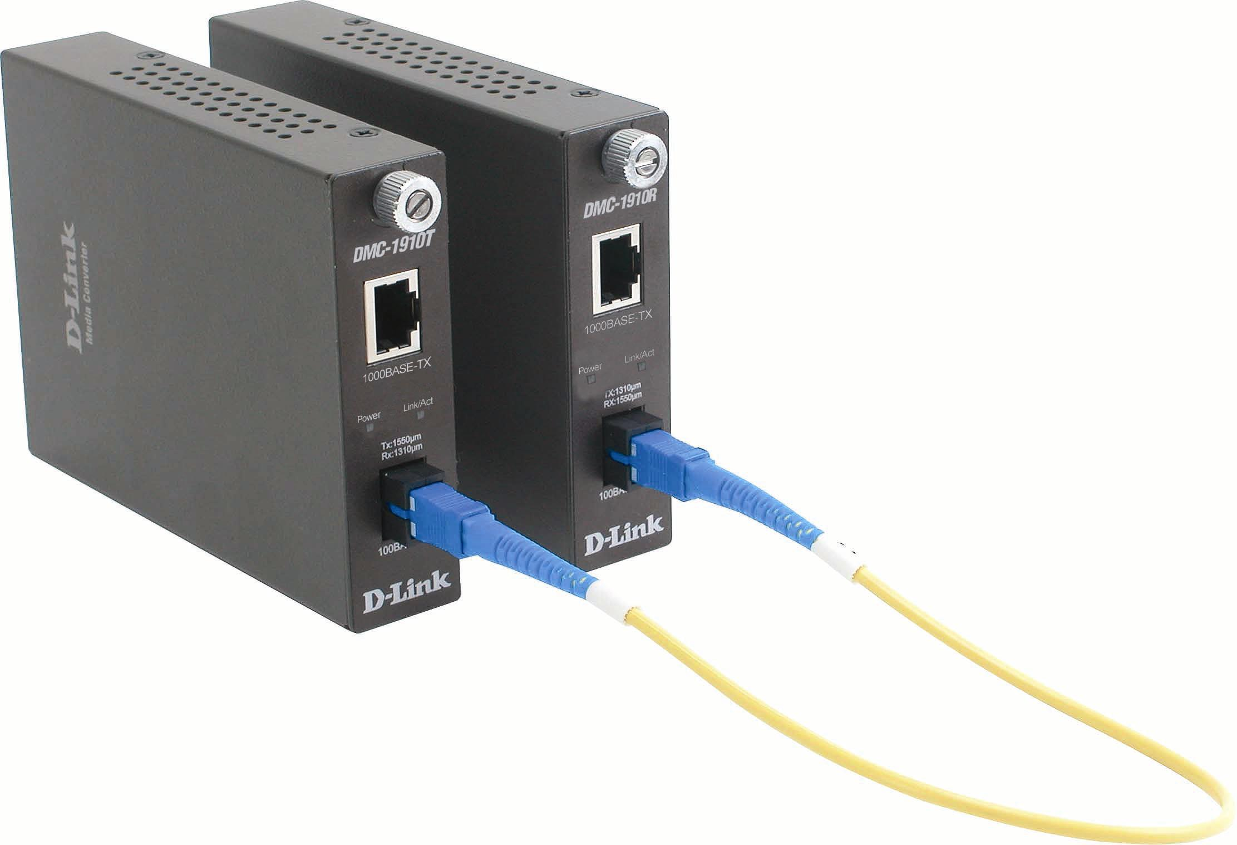
Why Sell This Product: | By marketing
Key Features: | By marketing
Technical Details: | By marketing
EMI/EMC Report | ■ FCC No.  CE No.  VCCI No.  ◻ CTR-21 No.  C-Tick No. ◻ A-Tick No.  ◻ FDA No. ◻ R&TTE No. ◻ BSMI No.  ◻ Others
Safety | ◻ TUV No. □ CUL No. ◻ CSA No.  ◻ Others
Packaging Style | ◻ Clamshell ◻ White Box◻ Gift Box ◻ Bulk   Others(Brown Box)
Packaging Contents: | - DMC-1910R and DMC-1910T Single-Fiber Media Converter  - AC power adapter x 2  - Manual x 1  - Quick Installation Guide x 1
UPC Code:
  IMC1910E..A1 | 790069 281587
  IMC1910N..A1 | 790069 281594
  IMC1910A..A1 | 790069 281600
  IMC1910B..A1 | 790069 281617
  EMC1910E..A1 | 790069 281624
  EMC1910B..A1 | 790069 281631
  NMC1910CN.A1 | 790069 281648
  TMC1910A..A1 | 790069 281655
  BMC1910A..A1 | 790069 281662
Units Per Carton: | 5
Cartons Per Pallet: | For USA Air:20, Sea: 32 | For WW Air:20, Sea: 32
Cartons Per Pallet: | For UK Air:32, Sea: 32
Dimensions and Weight: | Box:  mm,Others 275mm x 207mm x 117mm, 2.35 __ kg  Carton: 628 x 291 x 227 mm, 12.82 __ kg  Pallet: (by Air) 1220 x 1020 x 1650 mm,__275___ kg (for USA)  1200 x 1100 x 1650 mm, 275 kg (for WW), 1100 x 1200 x 2200 mm, __431__kg (for UK)  (by Sea) 1220 x 1020 x 2000 mm, _431___ kg (for USA)  1200 x 1100 x 2000 mm, _431__ kg (for WW), 1100 x 1200 x 2200 mm, __431__kg (for UK)  INTRASTAT weight: 2.1 kg (Box)  Packing material weight (Box):  - Paper: 0.4 kg  - Plastic: 0.002 kg  - Mixed: 0.005 kg

Approved | Checked | PM
 |  | Abbie Lin

