DMC-300SC

Test Report

PREFACE
This document describes the testing procedures that TEST LAB uses to test the Ethernet Media Converter. For IEEE802.3 u 100BASE-TX & 100BASE-FX the max. length of the Fast Ethernet Media Converter is 100M. The different sections of the plan are described in more details on the following:
This document consists of sections described below.
Section 1: Testing Environment
Section 2: Test Item
Section 3: Test Method

1.0 TESTING ENVIRONMENT
1.1 H/W REQUIREMENT

To test the Media Converter, we must have a computer system, network cards, devices, unshielded twisted-pair wire that it is enough to build a small network consisting of one NetWare Server and max. of one workstation.

1.2 S/W REQUIREMENT

‧MS-DOS Ver. 6.22
‧NOVELL Netware Server. 4.11
‧NOVELL Performance program Ver.1.61
‧NOVELL Endurance program Ver.1.03
‧SmartWindow, SmartApplication, Advanced Switch Test.
‧WebCom STG-104 (STG104.EXE) Ver.1.18
(The program can generates valid packets; packet size is between 64 bytes and 1518 bytes.)
1.3 LIST OF EQUIPMENTS

Server Equipment:

Make & Model: GA-586TX3 CPU Speed: AMD-K6™ 266 .

Bus Type: PCI Amount of Memory: 640K .

NetWare Version: 4.11 Adapter/Driver Name: AT-2560FX

Workstations Equipment:

SPEC.  WKS NO. | TYPE & CPU SPEED | ADAPTER NAME / REVISION | DRIVER FILE NAME
WKS 1 | Pentium II 350 MHz+640K RAM | Realtek 8139C | RTSODI

Media Converter:

DMC-300SC
TP FIBER
MARVELL AGILENT
88E6050-RJJ HFBR 5803
T05676.11 MALAYSIA
0102 ATP 0050
PCB Rev. A1

AC-DC ADAPTER:

MODEL NO : DV-751A5
INPUT : 120V 60Hz 200mA
OUTPUT : DC 7.5V 1.5A
LEVEL 3
I.T.E POWER SUPPLY
2.0 TEST ITEM
2.1 H/W PART

2.1.1 NIC Basic Self-Test

2.1.2 Basic Standard Test

‧Port Test
‧Horizontal cascading Test

2.1.3 Enhanced Standard Test

‧Enhanced single Media Converter Test

2.1.4 External Components Testing

‧Front Panel Indications Test

2.1.5 Enhanced Hardware Compatible Test

•TP port NIC/Hub/Switch Compatible Test
•Fiber Port Fiber Optic Transceiver compatible test

2.1.6 Abnormal Modes Test

‧Power ON/OFF(self-Test) Test
‧Network Cable Connect/Disconnect Test

2.1.7 Performance Test

2.1.8 SmartBits Advanced Tests

‧X-Stream Test
‧Backbone Test

2.1.9 UTP cable and STP cable test

2.1.10 Cable length test

3.0 TEST METHOD

3.1 H/W PART

3.1.1 NIC Basic Self-Test

Test Configuration : Connect two NICs in each computer with 100m crossover CAT5 UTP
cable.
Test Tools : WebCom STG104.EXE
Test Object : Be sure all computers are working normally before starting testing.
Test Procedure : Run STG104 program to test each computer
Pass/Fail Criteria : Without lose packet after 30 min/lose any packet after 30min.

ITEM | OK/  FAIL |  | NOTE

SECTION 1: NIC Basic Self-Testing
NIC Self-Test
30 minutes NIC Self-Test |  | 

3.1.2 Basic Standard Test

.UTP ports test
Test Configuration : Connect two DMC-300SC via 62.5/125um multi-mode fiber cable
with 2Km. One computer with two NICs, one NIC connects one UTP port
with 100mUTP cable, the other NIC connects another UTP port with 100m
UTP cable.
Test Tools : WebCom STG104.EXE
Test Object : Check the transmission/reception functions of all UTP ports of the Media
Converter.
Test Procedure : Run STG104 and test in pairs
Pass/Fail Criteria : Without lose packet after 5 min./lose any packet after 5 min.

‧Horizontal Cascading Switch test.

.Two Media Converter Count For UTP Ports Test
Test Configuration : Cascade two DMC-300SC via 62.5/125um multi-mode fiber optic cable
with 2Km.
Test Tools : WebCom STG104.EXE
Test Object : Simulate heavy traffic to check the reliability of the DMC-300SC in
two Media Converter count.
Test Procedure : Run STG104 and monitor each computer whether loses any packet or
not.
Pass/Fail Criteria : Without lose packet after 12 hours/lose any packet after 12 hours.

ITEM |  |  | OK/  FAIL | NOTE

SECTION 2: Basic Standard Testing

Ports Test
1.UTP/FIBER port Test | a. UTP Port Test | 
1.UTP/FIBER port Test | b. FIBER Port Test | 

Horizontal Cascading Test
Two DMC-300SC Count For Fiber Ports Test |  | 
3.1.3 Enhance Standard Test

‧Enhance single Media Converter Test
Test Configuration : One server connect fiber port with 2Km of 62.5/125um multi-mode
fiber optic cable, and one workstation connect UTP port with 100m
UTP cable through the Media Converter.
Test Tools : NOVELL Endurnce.EXE
Test Object : Test the endurance ability of DMC-300SC
Test procedure : One workstation connect UTP ports with 100m UTP cables run the
Endurnce.EXE program through DMC-300SC for 72 hours.
Pass/Fail Criteria : All workstations work well/any connection hangs up.

ITEM | OK/  FAIL | NOTE

SECTION 3: Enhanced Standard Testing
Enhanced Single Switch Test | 

3.1.4 External component Test

‧Front Panel Indications Test
Test Configuration : Two DMC-300SC
Test Tools : WebCom STG104.EXE
Test Object : Check front panel indications
Test Procedure : Power-cycle reset and connects UTP cable and Transmitting /
Receiving data
Pass/Fail Criteria : All front panel LEDs work well/any LED displays error.

ITEM | OK/  FAIL |  |  | NOTE

SECTION 4: External Components Testing
Front Panel Indications Test
TP
1. 100 LED Test |  | 
2. FDX LED Test |  | 
3. LINK/ACT LED Test |  | 
4. MDI & MDIX Auto-Sense |  | 
FIBER
1. Power LED Test |  | 
2. FDX LED Test |  | 
3. LINK/ACT LED Test |  | 

3.1.5 Enhanced Hardware Compatible Test
•TP Port
NIC/HUB/SWITCH compatible test
Test Configuration : NIC, try to use each NIC to connect with DMC-300SC by 1/115m UTP
Cable. HUB/SWITCH, Try to use each HUB/SWITCH to cascade
with DMC-300SC by 1/115m UTP Cable.
Test Tools : NOVELL Endurnce.EXE
Test Object : Test the compatible ability with NIC/HUB/SWITCH.
Test procedure : Run Endurnce.EXE programs by each NIC and HUB/SWITCH
cascaded with DMC-300SC counts for 10min.
Pass/Fail Criteria : Workstations work well/any connection hangs up.

ITEM |  | OK/FAIL

SECTION 5: Enhanced Hardware Compatible Testing
Chipset
Chipset | Driver Name |  | 1M | 115M
SN2000 NIC Compatible Test | SN2000 |  |  | 
3Com NIC 3C595 Compatible Test | 3C59X |  |  | 
3Com NIC 3C905C Compatible Test | 3C90X |  |  | 
Realtek 8139A Compatible Test | RTSODI |  |  | 
Realtek 8139B Compatible Test | RTSODI |  |  | 
Realtek 8139C Compatible Test | RTSODI |  |  | 
Intel21143+KS8761 Compatible Test | DC21X4 |  |  | 
Intel21143+XTHETE2101Compatible Test | DC21X4 |  |  | 
Intel21143+SEEQ80223 Compatible Test | DC21X4 |  |  | 
Intel21140+ST10040 Compatible Test | DC21X4 |  |  | 
Intel21140+NS83223 Compatible Test | DC21X4 |  |  | 
Winbond 840+BCM5202 Compatible Test | 840-OD |  |  | 
Winbond 840+DM9101F Compatible Test | 840-OD |  |  | 
Intel82557+NS83223 Compatible Test | E100BODI |  |  | 
Intel 82559 Compatible Test | E100BODI |  |  | 
Realtek 8029 Compatible Test | PCIODI |  |  | 
Realtek 8019 Compatible Test | PNPODI |  |  | 
Davicom DM9102AF Compatible Test | DM9PCI |  |  | 
Davicom DM9101F+VIA Compatible Test | FETPCI |  |  | 
NS83815 Compatible Test | C83815 |  |  | 

Hub/Switch | 1M | 115M
Winbond 89C982AF |  | 
Realtek8308+AtimaAC104R |  | 
Realtek8308+Am79c875kc |  | 
Realtek8308+Realtek8024 |  | 
F3FD6606S+SEEQ84225 |  | 
F3FD6606S+SEEQ80225 |  | 
ADMtek AL968+SEEQ84221 |  | 
Broadcom BCM5308 |  | 
F3+LU3X51 |  | 
F3+LU3X54 |  | 
Aten AT8985+SEEQ84221 |  | 
Atima AC108 |  | 
TamarackTC6097-5+MicroLink ML6692CH |  | 
Levelone LXT980QC |  | 
MX98741FC+Motorola XC68836 |  | 
MX98741FC+ICS 1887M |  | 
MX98745FC+GPS NWK914BCG |  | 
NS DP83850+NS DP83840 |  | 
Levelone LXT970QC |  | 
Lucent T7241A |  | 
3Com Super Stack II |  | 
DS-IC 2750+Levelone ST10040QC |  | 
AllaerAL100+BCM5202KPF |  | 
Broadcom BCM 5315 | X | 
KENDIN KS8735 |  | 
TNETX2004PAC+TNETX3100PGX |  | 
MARVELL 88E6050 |  | 
KENDIN KS8995 |  | 

•Fiber Port
Fiber Optic Transceiver compatible test
Test Configuration : Try to use each Fiber Optic Transceiver to connect with
DMC-300SC by 0.3m/2Km of 62.5/125um multi - mode
fiber optic cable.
Test Tools : NOVELL Endurnce.EXE
Test Object : Test the compatible ability with Fiber Optic Transceiver.
Test procedure : Run Endurnce.EXE programs by each Fiber Optic Transceiver
cascaded with DMC-300SC counts for 10min.
Pass/Fail Criteria : Workstations work well/any connection hangs up.

NIC/Switch/Fiber Optic Transceiver | 0.3M | 2KM
AT-2560FX  S82557+HP 5103T |  | 
EZ-SW16/F  TC6216M+AGILENT HFBR 5103 |  | 
3Com  Supper Stack II+3C16920(Module)  (Switch 1000)  LUCENT 1242F2+HP HFBE 5103 |  | 
DES-2208+ES-220FX(Module)  ET9618DNC4+AMP 269080-1 |  | 
MC100TMM  IC⁺ TP112+AGILENT HFBR 5903 |  | 
MC100TMC  IC⁺ TP112+AGILENT HFCT 5103 |  | 
MC110TMM  MARVELL 88E6050-RJJ+AGILENT HFBR 5903 |  | 
DMC-300SC  MARVELL 88E6050-RJJ+AGILENT HFBR 5803 |  | 
MC120TSC/15  AGILENT HFBR 5103 |  | 

3.1.6 Abnormal Test

It is to simulate end user abnormal operation.
. Power on/off
Test Configuration :Same as the Basic Standard Test Single Media Converter Test
Test Tools :WebCom STG104.EXE
Test Object :Check all functions of the Media Converter are normal after
power OFF/ON operation.
Test Procedure :Power OFF the Media Converter when the Media Converter is
Transmitting/Receiving, then Power ON the Media Converter,
and check all functions of the Media Converter.
Pass/Fail Criteria :All functions are normal after Power ON/any function is abnormal after
Power ON.

. Link/Unlink
Test Configuration : Same as the Basic Standard Test-Single Media Converter Test
Test Tools : WebCom STG104.EXE
Test Object : Check Transmission/Reception functions are normal after
disconnection/connection operation.
Test Procedure : Disconnecting the Media Converter with the UTP/FIBER cable when
the Media Converter is Transmitting/Receiving, then connecting the
Media Converter with the original UTP/FIBER cable, check the
transmission/Reception functions of the port.
Pass/Fail Criteria : Transmission/Reception functions are normal after unlink/link
Transmission or Reception function is abnormal.

ITEM | OK/  FAIL |  | NOTE

SECTION 6: Abnormal Test
1.Power ON/OFF (Self-Test) Test |  | 
2.Network Cable Connect/Disconnect Test |  | 

3.1.7 Performance Test

Test Configuration : Single Media Converter
Test Tools : NOVELL Perform3.EXE.
Test Object : Compare the performance of one device to sample device.
Test Procedure : Run PERFORM3 on one workstation, these workstation connect to
the DMC-300SC

ITEM |  |  | OK/  FAIL
SECTION 7: Performance Test
. Run PERFORM3 Test | Server NIC: 100M full duplex.  Clients NIC: 100M full duplex. | Max. :6217.36 KBPS
. Run PERFORM3 Test |  | Average :4006.54KBPS
. Run PERFORM3 Test | Server NIC: 100M full duplex.  Clients NIC: 10M full duplex. | Max. : 1019.21KBPS
. Run PERFORM3 Test | Server NIC: 100M full duplex.  Clients NIC: 10M full duplex. | Average : 850.07KBPS
. Run PERFORM3 Test | Server NIC: 100M half duplex.  Clients NIC: 100M half duplex. | Max. :6038.76 KBPS
. Run PERFORM3 Test |  | Average :3854.63KBPS
. Run PERFORM3 Test | Server NIC: 100M half duplex.  Clients NIC: 10M half duplex. | Max. :1019.88 KBPS
. Run PERFORM3 Test | Server NIC: 100M half duplex.  Clients NIC: 10M half duplex. | Average : 850.60KBPS

Server Equipment:

Make & Model: GA-586TX3 CPU Speed: AMD-K6™ 266 .

Bus Type: PCI Amount of Memory: 640KM .

NetWare Version: 4.11 Adapter/Driver Name: AT-2560FX

Workstations Equipment:

SPEC.  WKS NO. | TYPE & CPU SPEED | ADAPTER NAME / REVISION | DRIVER FILE NAME
WKS 1 | Pentium II 350 MHz+640K RAM | Realtek 8139C | RTSODI

Server NIC:100M full duplex.
Clients NIC:100M full duplex.
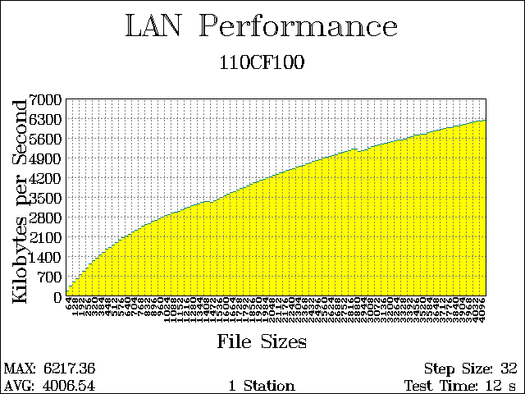
4096 bytes. 6217.36 KBps. 6217.36 Aggregate KBps.
4064 bytes. 6198.94 KBps. 6198.94 Aggregate KBps.
4032 bytes. 6178.62 KBps. 6178.62 Aggregate KBps.
4000 bytes. 6150.14 KBps. 6150.14 Aggregate KBps.
3968 bytes. 6123.92 KBps. 6123.92 Aggregate KBps.
3936 bytes. 6105.40 KBps. 6105.40 Aggregate KBps.
3904 bytes. 6069.45 KBps. 6069.45 Aggregate KBps.
3872 bytes. 6054.74 KBps. 6054.74 Aggregate KBps.
3840 bytes. 6017.23 KBps. 6017.23 Aggregate KBps.
3808 bytes. 6004.06 KBps. 6004.06 Aggregate KBps.
3776 bytes. 5965.56 KBps. 5965.56 Aggregate KBps.
3744 bytes. 5943.16 KBps. 5943.16 Aggregate KBps.
3712 bytes. 5915.08 KBps. 5915.08 Aggregate KBps.
3680 bytes. 5890.81 KBps. 5890.81 Aggregate KBps.
3648 bytes. 5857.01 KBps. 5857.01 Aggregate KBps.
3616 bytes. 5839.53 KBps. 5839.53 Aggregate KBps.
3584 bytes. 5814.62 KBps. 5814.62 Aggregate KBps.
3552 bytes. 5789.07 KBps. 5789.07 Aggregate KBps.
3520 bytes. 5724.31 KBps. 5724.31 Aggregate KBps.
3488 bytes. 5719.83 KBps. 5719.83 Aggregate KBps.
3456 bytes. 5690.17 KBps. 5690.17 Aggregate KBps.
3424 bytes. 5683.82 KBps. 5683.82 Aggregate KBps.
3392 bytes. 5642.32 KBps. 5642.32 Aggregate KBps.
3360 bytes. 5616.23 KBps. 5616.23 Aggregate KBps.
3328 bytes. 5561.47 KBps. 5561.47 Aggregate KBps.
3296 bytes. 5524.58 KBps. 5524.58 Aggregate KBps.
3264 bytes. 5517.54 KBps. 5517.54 Aggregate KBps.
3232 bytes. 5503.79 KBps. 5503.79 Aggregate KBps.
3200 bytes. 5466.79 KBps. 5466.79 Aggregate KBps.
3168 bytes. 5435.24 KBps. 5435.24 Aggregate KBps.
3136 bytes. 5401.55 KBps. 5401.55 Aggregate KBps.
3104 bytes. 5375.21 KBps. 5375.21 Aggregate KBps.
3072 bytes. 5349.37 KBps. 5349.37 Aggregate KBps.
3040 bytes. 5317.21 KBps. 5317.21 Aggregate KBps.
3008 bytes. 5275.00 KBps. 5274.99 Aggregate KBps.
2976 bytes. 5231.01 KBps. 5231.01 Aggregate KBps.
2944 bytes. 5173.09 KBps. 5173.09 Aggregate KBps.
2912 bytes. 5152.49 KBps. 5152.48 Aggregate KBps.
2880 bytes. 5118.89 KBps. 5118.89 Aggregate KBps.
2848 bytes. 5204.05 KBps. 5204.05 Aggregate KBps.
2816 bytes. 5187.12 KBps. 5187.12 Aggregate KBps.
2784 bytes. 5140.41 KBps. 5140.41 Aggregate KBps.
2752 bytes. 5113.88 KBps. 5113.88 Aggregate KBps.
2720 bytes. 5081.49 KBps. 5081.49 Aggregate KBps.
2688 bytes. 5040.09 KBps. 5040.09 Aggregate KBps.
2656 bytes. 5006.13 KBps. 5006.13 Aggregate KBps.
2624 bytes. 4976.86 KBps. 4976.86 Aggregate KBps.
2592 bytes. 4930.76 KBps. 4930.76 Aggregate KBps.
2560 bytes. 4906.72 KBps. 4906.72 Aggregate KBps.
2528 bytes. 4863.31 KBps. 4863.31 Aggregate KBps.
2496 bytes. 4825.52 KBps. 4825.52 Aggregate KBps.
2464 bytes. 4784.16 KBps. 4784.15 Aggregate KBps.
2432 bytes. 4750.60 KBps. 4750.60 Aggregate KBps.
2400 bytes. 4704.33 KBps. 4704.33 Aggregate KBps.
2368 bytes. 4664.19 KBps. 4664.19 Aggregate KBps.
2336 bytes. 4621.20 KBps. 4621.20 Aggregate KBps.
2304 bytes. 4592.29 KBps. 4592.29 Aggregate KBps.
2272 bytes. 4550.20 KBps. 4550.20 Aggregate KBps.
2240 bytes. 4510.30 KBps. 4510.30 Aggregate KBps.
2208 bytes. 4469.45 KBps. 4469.45 Aggregate KBps.
2176 bytes. 4429.48 KBps. 4429.48 Aggregate KBps.
2144 bytes. 4379.21 KBps. 4379.21 Aggregate KBps.
2112 bytes. 4347.27 KBps. 4347.27 Aggregate KBps.
2080 bytes. 4295.81 KBps. 4295.81 Aggregate KBps.
2048 bytes. 4262.10 KBps. 4262.10 Aggregate KBps.
2016 bytes. 4208.88 KBps. 4208.88 Aggregate KBps.
1984 bytes. 4168.13 KBps. 4168.13 Aggregate KBps.
1952 bytes. 4121.45 KBps. 4121.45 Aggregate KBps.
1920 bytes. 4081.49 KBps. 4081.49 Aggregate KBps.
1888 bytes. 4023.62 KBps. 4023.62 Aggregate KBps.
1856 bytes. 3990.38 KBps. 3990.38 Aggregate KBps.
1824 bytes. 3941.96 KBps. 3941.96 Aggregate KBps.
1792 bytes. 3898.68 KBps. 3898.68 Aggregate KBps.
1760 bytes. 3839.64 KBps. 3839.64 Aggregate KBps.
1728 bytes. 3800.61 KBps. 3800.61 Aggregate KBps.
1696 bytes. 3745.45 KBps. 3745.45 Aggregate KBps.
1664 bytes. 3691.98 KBps. 3691.98 Aggregate KBps.
1632 bytes. 3648.85 KBps. 3648.85 Aggregate KBps.
1600 bytes. 3587.36 KBps. 3587.36 Aggregate KBps.
1568 bytes. 3539.91 KBps. 3539.91 Aggregate KBps.
1536 bytes. 3487.59 KBps. 3487.59 Aggregate KBps.
1504 bytes. 3423.89 KBps. 3423.89 Aggregate KBps.
1472 bytes. 3362.65 KBps. 3362.65 Aggregate KBps.
1440 bytes. 3309.15 KBps. 3309.15 Aggregate KBps.
1408 bytes. 3344.80 KBps. 3344.80 Aggregate KBps.
1376 bytes. 3333.11 KBps. 3333.11 Aggregate KBps.
1344 bytes. 3290.68 KBps. 3290.68 Aggregate KBps.
1312 bytes. 3254.25 KBps. 3254.25 Aggregate KBps.
1280 bytes. 3213.27 KBps. 3213.27 Aggregate KBps.
1248 bytes. 3183.82 KBps. 3183.82 Aggregate KBps.
1216 bytes. 3137.80 KBps. 3137.80 Aggregate KBps.
1184 bytes. 3101.88 KBps. 3101.88 Aggregate KBps.
1152 bytes. 3044.42 KBps. 3044.42 Aggregate KBps.
1120 bytes. 2992.40 KBps. 2992.40 Aggregate KBps.
1088 bytes. 2961.24 KBps. 2961.24 Aggregate KBps.
1056 bytes. 2924.29 KBps. 2924.29 Aggregate KBps.
1024 bytes. 2859.73 KBps. 2859.73 Aggregate KBps.
992 bytes. 2822.50 KBps. 2822.50 Aggregate KBps.
960 bytes. 2781.51 KBps. 2781.51 Aggregate KBps.
928 bytes. 2709.11 KBps. 2709.11 Aggregate KBps.
896 bytes. 2664.47 KBps. 2664.47 Aggregate KBps.
864 bytes. 2618.59 KBps. 2618.58 Aggregate KBps.
832 bytes. 2555.92 KBps. 2555.92 Aggregate KBps.
800 bytes. 2511.74 KBps. 2511.74 Aggregate KBps.
768 bytes. 2454.14 KBps. 2454.14 Aggregate KBps.
736 bytes. 2380.16 KBps. 2380.16 Aggregate KBps.
704 bytes. 2309.59 KBps. 2309.59 Aggregate KBps.
672 bytes. 2248.07 KBps. 2248.07 Aggregate KBps.
640 bytes. 2179.35 KBps. 2179.35 Aggregate KBps.
608 bytes. 2118.75 KBps. 2118.75 Aggregate KBps.
576 bytes. 2041.92 KBps. 2041.92 Aggregate KBps.
544 bytes. 1953.08 KBps. 1953.07 Aggregate KBps.
512 bytes. 1866.71 KBps. 1866.71 Aggregate KBps.
480 bytes. 1788.46 KBps. 1788.46 Aggregate KBps.
448 bytes. 1708.99 KBps. 1708.99 Aggregate KBps.
416 bytes. 1629.31 KBps. 1629.31 Aggregate KBps.
384 bytes. 1524.73 KBps. 1524.73 Aggregate KBps.
352 bytes. 1429.17 KBps. 1429.17 Aggregate KBps.
320 bytes. 1326.62 KBps. 1326.62 Aggregate KBps.
288 bytes. 1223.03 KBps. 1223.03 Aggregate KBps.
256 bytes. 1105.33 KBps. 1105.32 Aggregate KBps.
224 bytes. 984.07 KBps. 984.07 Aggregate KBps.
192 bytes. 861.92 KBps. 861.92 Aggregate KBps.
160 bytes. 736.16 KBps. 736.16 Aggregate KBps.
128 bytes. 600.94 KBps. 600.94 Aggregate KBps.
96 bytes. 461.00 KBps. 461.00 Aggregate KBps.
64 bytes. 316.90 KBps. 316.90 Aggregate KBps.
32 bytes. 160.64 KBps. 160.64 Aggregate KBps.
6217.36 Maximum KBps. 4006.54 Average KBps.
Server NIC:100M full duplex.
Clients NIC:10M full duplex.
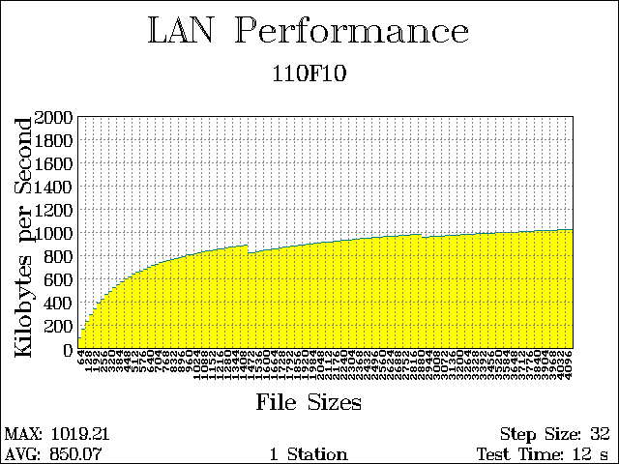
4096 bytes. 1019.21 KBps. 1019.21 Aggregate KBps.
4064 bytes. 1017.88 KBps. 1017.88 Aggregate KBps.
4032 bytes. 1016.78 KBps. 1016.78 Aggregate KBps.
4000 bytes. 1014.71 KBps. 1014.71 Aggregate KBps.
3968 bytes. 1013.39 KBps. 1013.39 Aggregate KBps.
3936 bytes. 1012.80 KBps. 1012.80 Aggregate KBps.
3904 bytes. 1011.25 KBps. 1011.25 Aggregate KBps.
3872 bytes. 1009.91 KBps. 1009.91 Aggregate KBps.
3840 bytes. 1007.62 KBps. 1007.62 Aggregate KBps.
3808 bytes. 1006.36 KBps. 1006.36 Aggregate KBps.
3776 bytes. 1005.51 KBps. 1005.51 Aggregate KBps.
3744 bytes. 999.31 KBps. 999.31 Aggregate KBps.
3712 bytes. 1002.10 KBps. 1002.10 Aggregate KBps.
3680 bytes. 999.53 KBps. 999.53 Aggregate KBps.
3648 bytes. 997.68 KBps. 997.68 Aggregate KBps.
3616 bytes. 997.13 KBps. 997.13 Aggregate KBps.
3584 bytes. 995.61 KBps. 995.61 Aggregate KBps.
3552 bytes. 993.97 KBps. 993.97 Aggregate KBps.
3520 bytes. 991.37 KBps. 991.36 Aggregate KBps.
3488 bytes. 990.03 KBps. 990.03 Aggregate KBps.
3456 bytes. 988.82 KBps. 988.82 Aggregate KBps.
3424 bytes. 987.20 KBps. 987.20 Aggregate KBps.
3392 bytes. 985.45 KBps. 985.45 Aggregate KBps.
3360 bytes. 982.73 KBps. 982.73 Aggregate KBps.
3328 bytes. 981.24 KBps. 981.24 Aggregate KBps.
3296 bytes. 979.34 KBps. 979.34 Aggregate KBps.
3264 bytes. 977.29 KBps. 977.29 Aggregate KBps.
3232 bytes. 975.33 KBps. 975.33 Aggregate KBps.
3200 bytes. 973.24 KBps. 973.24 Aggregate KBps.
3168 bytes. 971.55 KBps. 971.55 Aggregate KBps.
3136 bytes. 969.92 KBps. 969.92 Aggregate KBps.
3104 bytes. 967.87 KBps. 967.87 Aggregate KBps.
3072 bytes. 965.11 KBps. 965.11 Aggregate KBps.
3040 bytes. 962.99 KBps. 962.98 Aggregate KBps.
3008 bytes. 961.25 KBps. 961.25 Aggregate KBps.
2976 bytes. 959.28 KBps. 959.28 Aggregate KBps.
2944 bytes. 956.89 KBps. 956.89 Aggregate KBps.
2912 bytes. 954.01 KBps. 954.01 Aggregate KBps.
2880 bytes. 949.16 KBps. 949.16 Aggregate KBps.
2848 bytes. 977.97 KBps. 977.97 Aggregate KBps.
2816 bytes. 975.71 KBps. 975.71 Aggregate KBps.
2784 bytes. 973.48 KBps. 973.48 Aggregate KBps.
2752 bytes. 970.46 KBps. 970.46 Aggregate KBps.
2720 bytes. 968.49 KBps. 968.49 Aggregate KBps.
2688 bytes. 966.67 KBps. 966.67 Aggregate KBps.
2656 bytes. 964.26 KBps. 964.26 Aggregate KBps.
2624 bytes. 962.06 KBps. 962.06 Aggregate KBps.
2592 bytes. 958.62 KBps. 958.62 Aggregate KBps.
2560 bytes. 956.18 KBps. 956.18 Aggregate KBps.
2528 bytes. 954.29 KBps. 954.29 Aggregate KBps.
2496 bytes. 951.38 KBps. 951.38 Aggregate KBps.
2464 bytes. 948.23 KBps. 948.23 Aggregate KBps.
2432 bytes. 944.65 KBps. 944.65 Aggregate KBps.
2400 bytes. 942.40 KBps. 942.40 Aggregate KBps.
2368 bytes. 939.68 KBps. 939.68 Aggregate KBps.
2336 bytes. 936.70 KBps. 936.70 Aggregate KBps.
2304 bytes. 933.46 KBps. 933.46 Aggregate KBps.
2272 bytes. 930.10 KBps. 930.10 Aggregate KBps.
2240 bytes. 927.81 KBps. 927.81 Aggregate KBps.
2208 bytes. 924.47 KBps. 924.47 Aggregate KBps.
2176 bytes. 921.37 KBps. 921.36 Aggregate KBps.
2144 bytes. 916.85 KBps. 916.84 Aggregate KBps.
2112 bytes. 913.15 KBps. 913.15 Aggregate KBps.
2080 bytes. 909.90 KBps. 909.90 Aggregate KBps.
2048 bytes. 906.43 KBps. 906.43 Aggregate KBps.
2016 bytes. 902.96 KBps. 902.96 Aggregate KBps.
1984 bytes. 898.40 KBps. 898.40 Aggregate KBps.
1952 bytes. 894.25 KBps. 894.25 Aggregate KBps.
1920 bytes. 891.45 KBps. 891.45 Aggregate KBps.
1888 bytes. 887.99 KBps. 887.99 Aggregate KBps.
1856 bytes. 883.69 KBps. 883.69 Aggregate KBps.
1824 bytes. 878.73 KBps. 878.73 Aggregate KBps.
1792 bytes. 874.27 KBps. 874.27 Aggregate KBps.
1760 bytes. 870.43 KBps. 870.43 Aggregate KBps.
1728 bytes. 866.17 KBps. 866.16 Aggregate KBps.
1696 bytes. 860.92 KBps. 860.92 Aggregate KBps.
1664 bytes. 854.82 KBps. 854.82 Aggregate KBps.
1632 bytes. 849.29 KBps. 849.29 Aggregate KBps.
1600 bytes. 844.95 KBps. 844.95 Aggregate KBps.
1568 bytes. 839.95 KBps. 839.95 Aggregate KBps.
1536 bytes. 833.71 KBps. 833.71 Aggregate KBps.
1504 bytes. 827.92 KBps. 827.92 Aggregate KBps.
1472 bytes. 822.30 KBps. 822.30 Aggregate KBps.
1440 bytes. 816.49 KBps. 816.49 Aggregate KBps.
1408 bytes. 883.35 KBps. 883.35 Aggregate KBps.
1376 bytes. 879.67 KBps. 879.67 Aggregate KBps.
1344 bytes. 874.16 KBps. 874.16 Aggregate KBps.
1312 bytes. 870.01 KBps. 870.01 Aggregate KBps.
1280 bytes. 865.39 KBps. 865.39 Aggregate KBps.
1248 bytes. 860.66 KBps. 860.66 Aggregate KBps.
1216 bytes. 854.25 KBps. 854.25 Aggregate KBps.
1184 bytes. 849.62 KBps. 849.62 Aggregate KBps.
1152 bytes. 844.17 KBps. 844.17 Aggregate KBps.
1120 bytes. 838.63 KBps. 838.63 Aggregate KBps.
1088 bytes. 832.87 KBps. 832.87 Aggregate KBps.
1056 bytes. 826.46 KBps. 826.46 Aggregate KBps.
1024 bytes. 819.45 KBps. 819.45 Aggregate KBps.
992 bytes. 813.85 KBps. 813.85 Aggregate KBps.
960 bytes. 805.84 KBps. 805.84 Aggregate KBps.
928 bytes. 797.83 KBps. 797.83 Aggregate KBps.
896 bytes. 789.03 KBps. 789.03 Aggregate KBps.
864 bytes. 780.72 KBps. 780.72 Aggregate KBps.
832 bytes. 772.45 KBps. 772.45 Aggregate KBps.
800 bytes. 763.17 KBps. 763.17 Aggregate KBps.
768 bytes. 752.76 KBps. 752.76 Aggregate KBps.
736 bytes. 742.75 KBps. 742.75 Aggregate KBps.
704 bytes. 731.57 KBps. 731.57 Aggregate KBps.
672 bytes. 720.78 KBps. 720.78 Aggregate KBps.
640 bytes. 707.39 KBps. 707.39 Aggregate KBps.
608 bytes. 694.35 KBps. 694.34 Aggregate KBps.
576 bytes. 679.08 KBps. 679.08 Aggregate KBps.
544 bytes. 659.41 KBps. 659.41 Aggregate KBps.
512 bytes. 648.29 KBps. 648.29 Aggregate KBps.
480 bytes. 631.74 KBps. 631.73 Aggregate KBps.
448 bytes. 612.43 KBps. 612.43 Aggregate KBps.
416 bytes. 591.67 KBps. 591.67 Aggregate KBps.
384 bytes. 569.64 KBps. 569.64 Aggregate KBps.
352 bytes. 544.80 KBps. 544.80 Aggregate KBps.
320 bytes. 517.65 KBps. 517.65 Aggregate KBps.
288 bytes. 489.45 KBps. 489.45 Aggregate KBps.
256 bytes. 456.57 KBps. 456.57 Aggregate KBps.
224 bytes. 422.66 KBps. 422.66 Aggregate KBps.
192 bytes. 382.63 KBps. 382.63 Aggregate KBps.
160 bytes. 338.23 KBps. 338.23 Aggregate KBps.
128 bytes. 287.95 KBps. 287.95 Aggregate KBps.
96 bytes. 231.03 KBps. 231.02 Aggregate KBps.
64 bytes. 161.80 KBps. 161.79 Aggregate KBps.
32 bytes. 88.50 KBps. 88.50 Aggregate KBps.
1019.21 Maximum KBps. 850.07 Average KBps.
Server NIC:100M half duplex.
Clients NIC:100M half duplex.
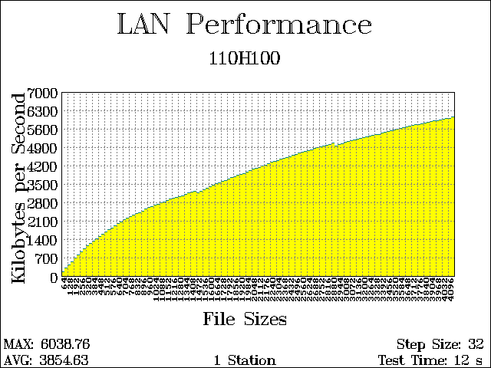
4096 bytes. 6038.76 KBps. 6038.76 Aggregate KBps.
4064 bytes. 5993.41 KBps. 5993.41 Aggregate KBps.
4032 bytes. 5982.83 KBps. 5982.83 Aggregate KBps.
4000 bytes. 5963.06 KBps. 5963.06 Aggregate KBps.
3968 bytes. 5931.95 KBps. 5931.95 Aggregate KBps.
3936 bytes. 5911.73 KBps. 5911.73 Aggregate KBps.
3904 bytes. 5885.33 KBps. 5885.33 Aggregate KBps.
3872 bytes. 5859.68 KBps. 5859.67 Aggregate KBps.
3840 bytes. 5831.28 KBps. 5831.28 Aggregate KBps.
3808 bytes. 5806.47 KBps. 5806.47 Aggregate KBps.
3776 bytes. 5779.24 KBps. 5779.24 Aggregate KBps.
3744 bytes. 5758.67 KBps. 5758.67 Aggregate KBps.
3712 bytes. 5741.90 KBps. 5741.90 Aggregate KBps.
3680 bytes. 5716.97 KBps. 5716.97 Aggregate KBps.
3648 bytes. 5689.29 KBps. 5689.29 Aggregate KBps.
3616 bytes. 5665.64 KBps. 5665.63 Aggregate KBps.
3584 bytes. 5636.81 KBps. 5636.81 Aggregate KBps.
3552 bytes. 5603.57 KBps. 5603.57 Aggregate KBps.
3520 bytes. 5570.65 KBps. 5570.65 Aggregate KBps.
3488 bytes. 5543.62 KBps. 5543.62 Aggregate KBps.
3456 bytes. 5520.96 KBps. 5520.96 Aggregate KBps.
3424 bytes. 5499.88 KBps. 5499.88 Aggregate KBps.
3392 bytes. 5461.20 KBps. 5461.20 Aggregate KBps.
3360 bytes. 5433.94 KBps. 5433.94 Aggregate KBps.
3328 bytes. 5385.33 KBps. 5385.33 Aggregate KBps.
3296 bytes. 5386.63 KBps. 5386.63 Aggregate KBps.
3264 bytes. 5353.56 KBps. 5353.56 Aggregate KBps.
3232 bytes. 5324.53 KBps. 5324.52 Aggregate KBps.
3200 bytes. 5296.57 KBps. 5296.57 Aggregate KBps.
3168 bytes. 5264.80 KBps. 5264.80 Aggregate KBps.
3136 bytes. 5232.60 KBps. 5232.60 Aggregate KBps.
3104 bytes. 5195.89 KBps. 5195.89 Aggregate KBps.
3072 bytes. 5170.37 KBps. 5170.37 Aggregate KBps.
3040 bytes. 5152.53 KBps. 5152.53 Aggregate KBps.
3008 bytes. 5115.47 KBps. 5115.47 Aggregate KBps.
2976 bytes. 5072.71 KBps. 5072.71 Aggregate KBps.
2944 bytes. 5020.21 KBps. 5020.21 Aggregate KBps.
2912 bytes. 4981.79 KBps. 4981.78 Aggregate KBps.
2880 bytes. 4922.69 KBps. 4922.69 Aggregate KBps.
2848 bytes. 5040.41 KBps. 5040.40 Aggregate KBps.
2816 bytes. 5001.92 KBps. 5001.92 Aggregate KBps.
2784 bytes. 4968.19 KBps. 4968.19 Aggregate KBps.
2752 bytes. 4945.85 KBps. 4945.85 Aggregate KBps.
2720 bytes. 4911.51 KBps. 4911.51 Aggregate KBps.
2688 bytes. 4880.92 KBps. 4880.92 Aggregate KBps.
2656 bytes. 4835.82 KBps. 4835.81 Aggregate KBps.
2624 bytes. 4796.61 KBps. 4796.60 Aggregate KBps.
2592 bytes. 4760.53 KBps. 4760.53 Aggregate KBps.
2560 bytes. 4736.44 KBps. 4736.44 Aggregate KBps.
2528 bytes. 4701.13 KBps. 4701.13 Aggregate KBps.
2496 bytes. 4665.05 KBps. 4665.05 Aggregate KBps.
2464 bytes. 4622.33 KBps. 4622.33 Aggregate KBps.
2432 bytes. 4576.79 KBps. 4576.79 Aggregate KBps.
2400 bytes. 4530.21 KBps. 4530.21 Aggregate KBps.
2368 bytes. 4503.87 KBps. 4503.87 Aggregate KBps.
2336 bytes. 4460.35 KBps. 4460.35 Aggregate KBps.
2304 bytes. 4426.32 KBps. 4426.31 Aggregate KBps.
2272 bytes. 4379.35 KBps. 4379.35 Aggregate KBps.
2240 bytes. 4353.27 KBps. 4353.27 Aggregate KBps.
2208 bytes. 4317.18 KBps. 4317.18 Aggregate KBps.
2176 bytes. 4253.20 KBps. 4253.19 Aggregate KBps.
2144 bytes. 4202.37 KBps. 4202.37 Aggregate KBps.
2112 bytes. 4169.76 KBps. 4169.76 Aggregate KBps.
2080 bytes. 4132.53 KBps. 4132.52 Aggregate KBps.
2048 bytes. 4099.92 KBps. 4099.92 Aggregate KBps.
2016 bytes. 4047.53 KBps. 4047.53 Aggregate KBps.
1984 bytes. 4008.05 KBps. 4008.05 Aggregate KBps.
1952 bytes. 3949.50 KBps. 3949.50 Aggregate KBps.
1920 bytes. 3898.85 KBps. 3898.85 Aggregate KBps.
1888 bytes. 3869.10 KBps. 3869.10 Aggregate KBps.
1856 bytes. 3831.08 KBps. 3831.08 Aggregate KBps.
1824 bytes. 3783.33 KBps. 3783.33 Aggregate KBps.
1792 bytes. 3743.36 KBps. 3743.36 Aggregate KBps.
1760 bytes. 3684.98 KBps. 3684.98 Aggregate KBps.
1728 bytes. 3636.79 KBps. 3636.79 Aggregate KBps.
1696 bytes. 3589.79 KBps. 3589.79 Aggregate KBps.
1664 bytes. 3539.70 KBps. 3539.70 Aggregate KBps.
1632 bytes. 3494.94 KBps. 3494.94 Aggregate KBps.
1600 bytes. 3441.80 KBps. 3441.80 Aggregate KBps.
1568 bytes. 3392.93 KBps. 3392.93 Aggregate KBps.
1536 bytes. 3344.11 KBps. 3344.11 Aggregate KBps.
1504 bytes. 3274.02 KBps. 3274.02 Aggregate KBps.
1472 bytes. 3218.30 KBps. 3218.30 Aggregate KBps.
1440 bytes. 3168.88 KBps. 3168.88 Aggregate KBps.
1408 bytes. 3218.67 KBps. 3218.67 Aggregate KBps.
1376 bytes. 3184.81 KBps. 3184.81 Aggregate KBps.
1344 bytes. 3147.81 KBps. 3147.81 Aggregate KBps.
1312 bytes. 3110.19 KBps. 3110.19 Aggregate KBps.
1280 bytes. 3053.88 KBps. 3053.88 Aggregate KBps.
1248 bytes. 3017.65 KBps. 3017.65 Aggregate KBps.
1216 bytes. 2995.44 KBps. 2995.44 Aggregate KBps.
1184 bytes. 2956.16 KBps. 2956.16 Aggregate KBps.
1152 bytes. 2913.73 KBps. 2913.73 Aggregate KBps.
1120 bytes. 2872.81 KBps. 2872.81 Aggregate KBps.
1088 bytes. 2817.36 KBps. 2817.35 Aggregate KBps.
1056 bytes. 2763.96 KBps. 2763.96 Aggregate KBps.
1024 bytes. 2724.04 KBps. 2724.04 Aggregate KBps.
992 bytes. 2688.00 KBps. 2688.00 Aggregate KBps.
960 bytes. 2639.33 KBps. 2639.33 Aggregate KBps.
928 bytes. 2589.66 KBps. 2589.66 Aggregate KBps.
896 bytes. 2533.99 KBps. 2533.99 Aggregate KBps.
864 bytes. 2464.20 KBps. 2464.20 Aggregate KBps.
832 bytes. 2407.59 KBps. 2407.59 Aggregate KBps.
800 bytes. 2357.06 KBps. 2357.06 Aggregate KBps.
768 bytes. 2299.81 KBps. 2299.81 Aggregate KBps.
736 bytes. 2242.48 KBps. 2242.48 Aggregate KBps.
704 bytes. 2184.74 KBps. 2184.74 Aggregate KBps.
672 bytes. 2125.80 KBps. 2125.80 Aggregate KBps.
640 bytes. 2057.28 KBps. 2057.28 Aggregate KBps.
608 bytes. 1979.76 KBps. 1979.76 Aggregate KBps.
576 bytes. 1899.67 KBps. 1899.67 Aggregate KBps.
544 bytes. 1826.21 KBps. 1826.20 Aggregate KBps.
512 bytes. 1760.81 KBps. 1760.81 Aggregate KBps.
480 bytes. 1675.05 KBps. 1675.05 Aggregate KBps.
448 bytes. 1589.51 KBps. 1589.51 Aggregate KBps.
416 bytes. 1506.65 KBps. 1506.65 Aggregate KBps.
384 bytes. 1408.60 KBps. 1408.60 Aggregate KBps.
352 bytes. 1326.84 KBps. 1326.84 Aggregate KBps.
320 bytes. 1228.62 KBps. 1228.62 Aggregate KBps.
288 bytes. 1131.41 KBps. 1131.41 Aggregate KBps.
256 bytes. 1023.02 KBps. 1023.02 Aggregate KBps.
224 bytes. 909.15 KBps. 909.15 Aggregate KBps.
192 bytes. 798.45 KBps. 798.45 Aggregate KBps.
160 bytes. 678.05 KBps. 678.05 Aggregate KBps.
128 bytes. 544.77 KBps. 544.77 Aggregate KBps.
96 bytes. 415.14 KBps. 415.14 Aggregate KBps.
64 bytes. 287.52 KBps. 287.52 Aggregate KBps.
32 bytes. 146.14 KBps. 146.14 Aggregate KBps.
6038.76 Maximum KBps. 3854.63 Average KBps.
Server NIC:100M half duplex.
Clients NIC:10M half duplex.
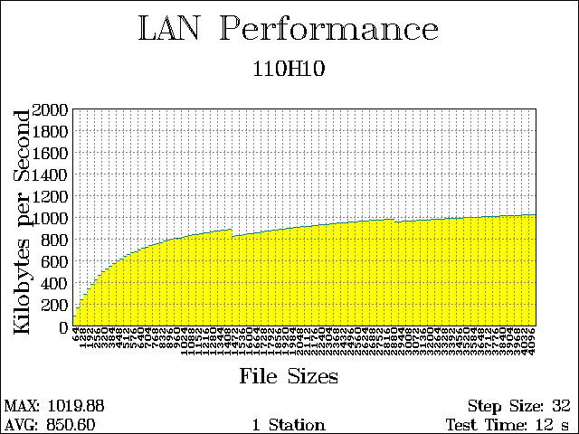
4096 bytes. 1019.88 KBps. 1019.88 Aggregate KBps.
4064 bytes. 1018.55 KBps. 1018.55 Aggregate KBps.
4032 bytes. 1017.11 KBps. 1017.10 Aggregate KBps.
4000 bytes. 1015.36 KBps. 1015.36 Aggregate KBps.
3968 bytes. 1014.03 KBps. 1014.03 Aggregate KBps.
3936 bytes. 1013.12 KBps. 1013.12 Aggregate KBps.
3904 bytes. 1011.57 KBps. 1011.57 Aggregate KBps.
3872 bytes. 1010.54 KBps. 1010.54 Aggregate KBps.
3840 bytes. 1008.24 KBps. 1008.24 Aggregate KBps.
3808 bytes. 1006.36 KBps. 1006.36 Aggregate KBps.
3776 bytes. 1005.82 KBps. 1005.82 Aggregate KBps.
3744 bytes. 1004.63 KBps. 1004.63 Aggregate KBps.
3712 bytes. 1002.70 KBps. 1002.70 Aggregate KBps.
3680 bytes. 1000.73 KBps. 1000.73 Aggregate KBps.
3648 bytes. 999.11 KBps. 999.11 Aggregate KBps.
3616 bytes. 997.42 KBps. 997.42 Aggregate KBps.
3584 bytes. 995.91 KBps. 995.91 Aggregate KBps.
3552 bytes. 993.43 KBps. 993.43 Aggregate KBps.
3520 bytes. 991.94 KBps. 991.94 Aggregate KBps.
3488 bytes. 991.14 KBps. 991.14 Aggregate KBps.
3456 bytes. 989.38 KBps. 989.38 Aggregate KBps.
3424 bytes. 987.76 KBps. 987.76 Aggregate KBps.
3392 bytes. 984.63 KBps. 984.63 Aggregate KBps.
3360 bytes. 983.01 KBps. 983.01 Aggregate KBps.
3328 bytes. 982.60 KBps. 982.60 Aggregate KBps.
3296 bytes. 980.68 KBps. 980.68 Aggregate KBps.
3264 bytes. 978.35 KBps. 978.35 Aggregate KBps.
3232 bytes. 976.12 KBps. 976.12 Aggregate KBps.
3200 bytes. 973.50 KBps. 973.50 Aggregate KBps.
3168 bytes. 972.58 KBps. 972.58 Aggregate KBps.
3136 bytes. 970.18 KBps. 970.17 Aggregate KBps.
3104 bytes. 968.13 KBps. 968.13 Aggregate KBps.
3072 bytes. 965.36 KBps. 965.36 Aggregate KBps.
3040 bytes. 963.23 KBps. 963.23 Aggregate KBps.
3008 bytes. 961.50 KBps. 961.50 Aggregate KBps.
2976 bytes. 959.77 KBps. 959.77 Aggregate KBps.
2944 bytes. 957.37 KBps. 957.37 Aggregate KBps.
2912 bytes. 954.25 KBps. 954.25 Aggregate KBps.
2880 bytes. 949.63 KBps. 949.63 Aggregate KBps.
2848 bytes. 978.90 KBps. 978.90 Aggregate KBps.
2816 bytes. 976.63 KBps. 976.63 Aggregate KBps.
2784 bytes. 974.39 KBps. 974.39 Aggregate KBps.
2752 bytes. 971.36 KBps. 971.36 Aggregate KBps.
2720 bytes. 969.96 KBps. 969.96 Aggregate KBps.
2688 bytes. 967.76 KBps. 967.76 Aggregate KBps.
2656 bytes. 964.69 KBps. 964.69 Aggregate KBps.
2624 bytes. 961.47 KBps. 961.47 Aggregate KBps.
2592 bytes. 958.83 KBps. 958.83 Aggregate KBps.
2560 bytes. 957.39 KBps. 957.39 Aggregate KBps.
2528 bytes. 954.50 KBps. 954.50 Aggregate KBps.
2496 bytes. 951.79 KBps. 951.78 Aggregate KBps.
2464 bytes. 948.44 KBps. 948.44 Aggregate KBps.
2432 bytes. 946.04 KBps. 946.03 Aggregate KBps.
2400 bytes. 943.77 KBps. 943.77 Aggregate KBps.
2368 bytes. 941.03 KBps. 941.03 Aggregate KBps.
2336 bytes. 937.47 KBps. 937.47 Aggregate KBps.
2304 bytes. 933.43 KBps. 933.43 Aggregate KBps.
2272 bytes. 930.28 KBps. 930.28 Aggregate KBps.
2240 bytes. 928.18 KBps. 928.18 Aggregate KBps.
2208 bytes. 924.65 KBps. 924.65 Aggregate KBps.
2176 bytes. 922.08 KBps. 922.08 Aggregate KBps.
2144 bytes. 917.54 KBps. 917.54 Aggregate KBps.
2112 bytes. 914.35 KBps. 914.35 Aggregate KBps.
2080 bytes. 907.06 KBps. 907.05 Aggregate KBps.
2048 bytes. 907.44 KBps. 907.43 Aggregate KBps.
2016 bytes. 903.62 KBps. 903.62 Aggregate KBps.
1984 bytes. 899.21 KBps. 899.21 Aggregate KBps.
1952 bytes. 895.05 KBps. 895.05 Aggregate KBps.
1920 bytes. 892.39 KBps. 892.39 Aggregate KBps.
1888 bytes. 888.30 KBps. 888.30 Aggregate KBps.
1856 bytes. 883.84 KBps. 883.84 Aggregate KBps.
1824 bytes. 878.88 KBps. 878.88 Aggregate KBps.
1792 bytes. 874.27 KBps. 874.27 Aggregate KBps.
1760 bytes. 870.43 KBps. 870.43 Aggregate KBps.
1728 bytes. 866.17 KBps. 866.16 Aggregate KBps.
1696 bytes. 861.19 KBps. 861.19 Aggregate KBps.
1664 bytes. 855.63 KBps. 855.63 Aggregate KBps.
1632 bytes. 851.60 KBps. 851.60 Aggregate KBps.
1600 bytes. 846.39 KBps. 846.39 Aggregate KBps.
1568 bytes. 841.36 KBps. 841.35 Aggregate KBps.
1536 bytes. 834.39 KBps. 834.39 Aggregate KBps.
1504 bytes. 829.14 KBps. 829.14 Aggregate KBps.
1472 bytes. 823.95 KBps. 823.95 Aggregate KBps.
1440 bytes. 816.38 KBps. 816.38 Aggregate KBps.
1408 bytes. 883.12 KBps. 883.12 Aggregate KBps.
1376 bytes. 878.60 KBps. 878.60 Aggregate KBps.
1344 bytes. 873.94 KBps. 873.94 Aggregate KBps.
1312 bytes. 870.86 KBps. 870.86 Aggregate KBps.
1280 bytes. 866.65 KBps. 866.65 Aggregate KBps.
1248 bytes. 861.47 KBps. 861.47 Aggregate KBps.
1216 bytes. 855.63 KBps. 855.63 Aggregate KBps.
1184 bytes. 849.33 KBps. 849.33 Aggregate KBps.
1152 bytes. 843.70 KBps. 843.70 Aggregate KBps.
1120 bytes. 838.27 KBps. 838.27 Aggregate KBps.
1088 bytes. 832.07 KBps. 832.07 Aggregate KBps.
1056 bytes. 825.77 KBps. 825.77 Aggregate KBps.
1024 bytes. 819.45 KBps. 819.45 Aggregate KBps.
992 bytes. 813.60 KBps. 813.60 Aggregate KBps.
960 bytes. 801.28 KBps. 801.28 Aggregate KBps.
928 bytes. 798.06 KBps. 798.06 Aggregate KBps.
896 bytes. 790.42 KBps. 790.42 Aggregate KBps.
864 bytes. 782.26 KBps. 782.26 Aggregate KBps.
832 bytes. 773.20 KBps. 773.20 Aggregate KBps.
800 bytes. 763.82 KBps. 763.82 Aggregate KBps.
768 bytes. 754.26 KBps. 754.26 Aggregate KBps.
736 bytes. 743.95 KBps. 743.95 Aggregate KBps.
704 bytes. 731.46 KBps. 731.46 Aggregate KBps.
672 bytes. 720.29 KBps. 720.28 Aggregate KBps.
640 bytes. 708.65 KBps. 708.65 Aggregate KBps.
608 bytes. 696.97 KBps. 696.97 Aggregate KBps.
576 bytes. 679.79 KBps. 679.79 Aggregate KBps.
544 bytes. 664.71 KBps. 664.71 Aggregate KBps.
512 bytes. 648.08 KBps. 648.08 Aggregate KBps.
480 bytes. 631.77 KBps. 631.77 Aggregate KBps.
448 bytes. 611.77 KBps. 611.77 Aggregate KBps.
416 bytes. 591.03 KBps. 591.03 Aggregate KBps.
384 bytes. 569.52 KBps. 569.52 Aggregate KBps.
352 bytes. 545.58 KBps. 545.58 Aggregate KBps.
320 bytes. 518.61 KBps. 518.61 Aggregate KBps.
288 bytes. 491.15 KBps. 491.15 Aggregate KBps.
256 bytes. 458.12 KBps. 458.12 Aggregate KBps.
224 bytes. 422.53 KBps. 422.53 Aggregate KBps.
192 bytes. 380.52 KBps. 380.52 Aggregate KBps.
160 bytes. 339.16 KBps. 339.15 Aggregate KBps.
128 bytes. 288.95 KBps. 288.95 Aggregate KBps.
96 bytes. 231.62 KBps. 231.62 Aggregate KBps.
64 bytes. 161.58 KBps. 161.57 Aggregate KBps.
32 bytes. 88.55 KBps. 88.55 Aggregate KBps.
1019.88 Maximum KBps. 850.60 Average KBps.
3.1.8 SmartBits Advanced Tests (X-Stream and Backbone Test)

Test Configuration : Cascade two DMC-300SC via 62.5/125um multi-mode fiber optic cable
with 2Km.
Test Tools : Advanced Switch Test.
Test Object : Test the Media Converter will loss packet or not and test the bandwidth of the
Media Converter. Every port send multicast to all the other ports, the line speed of
all the ports set to 100M full duplex
Test Procedure : Run the advanced switch test with smartbits.
Pass/Fail Criteria : No loss any packet/Loss any packet.

X-Stream Test (Every port send multicast to all the other ports, the line speed of all the ports set to
100M full duplex)
Netcom Systems, Advanced Switch Tests. |  |  |  |  | Version 2.10
Manufacturer : CAMEO
Type : DMC-300SC(Rev. A1)
Comments :
Tests run 2001/8/2 at 08:27:15 PM
Unit Test Time Duration: 10 s.
RESULTS
#Ports | #Addr./Port | Load | Frame Size | Burst Size | Transmit | Receive | # Loss | % Loss
2 | 1 | 80 | 64 | 24 | 2380952 | 2380952 | 0 | 0.00%
2 | 1 | 80 | 64 | 744 | 2380952 | 2380952 | 0 | 0.00%
2 | 1 | 80 | 1518 | 24 | 130040 | 130040 | 0 | 0.00%
2 | 1 | 80 | 1518 | 744 | 130040 | 130040 | 0 | 0.00%
2 | 1 | 90 | 64 | 24 | 2678572 | 2678572 | 0 | 0.00%
2 | 1 | 90 | 64 | 744 | 2678572 | 2678572 | 0 | 0.00%
2 | 1 | 90 | 1518 | 24 | 146294 | 146294 | 0 | 0.00%
2 | 1 | 90 | 1518 | 744 | 146294 | 146294 | 0 | 0.00%
2 | 1 | 100 | 64 | 24 | 2976190 | 2976184 | 6 | 0.00%
2 | 1 | 100 | 64 | 744 | 2976190 | 2976184 | 6 | 0.00%
2 | 1 | 100 | 1518 | 24 | 162548 | 162548 | 0 | 0.00%
2 | 1 | 100 | 1518 | 744 | 162548 | 162548 | 0 | 0.00%
2 | 1 | 150 | 64 | 24 | 4464286 | 4464269 | 17 | 0.00%
2 | 1 | 150 | 64 | 744 | 4464286 | 4464269 | 17 | 0.00%
2 | 1 | 150 | 1518 | 24 | 243824 | 243824 | 0 | 0.00%
2 | 1 | 150 | 1518 | 744 | 243824 | 243824 | 0 | 0.00%

Backbone Test (The 1 port 1 send/receive packets with the port 2 in the same time, the line speed of all the ports set to 100M full duplex )

Netcom Systems, Advanced Switch Tests.
Version 2.10
Manufacturer : CAMEO
Type : DMC-300SC(Rev. A1)
Comments :
Tests run 2001/8/2 at 08:19:24 PM
Unit Test Time Duration: 10 s.
RESULTS
#Ports | #Addr./Port | Load | Frame Size | Burst Size | Transmit | Receive | # Loss | % Loss
2 | 1 | 80 | 64 | 24 | 2380952 | 2380952 | 0 | 0.00%
2 | 1 | 80 | 64 | 744 | 2380952 | 2380952 | 0 | 0.00%
2 | 1 | 80 | 1518 | 24 | 130040 | 130040 | 0 | 0.00%
2 | 1 | 80 | 1518 | 744 | 130040 | 130040 | 0 | 0.00%
2 | 1 | 90 | 64 | 24 | 2678572 | 2678572 | 0 | 0.00%
2 | 1 | 90 | 64 | 744 | 2678572 | 2678572 | 0 | 0.00%
2 | 1 | 90 | 1518 | 24 | 146294 | 146294 | 0 | 0.00%
2 | 1 | 90 | 1518 | 744 | 146294 | 146294 | 0 | 0.00%
2 | 1 | 100 | 64 | 24 | 2976190 | 2976184 | 6 | 0.00%
2 | 1 | 100 | 64 | 744 | 2976190 | 2976184 | 6 | 0.00%
2 | 1 | 100 | 1518 | 24 | 162548 | 162548 | 0 | 0.00%
2 | 1 | 100 | 1518 | 744 | 162548 | 162548 | 0 | 0.00%
2 | 1 | 150 | 64 | 24 | 4464286 | 4464270 | 16 | 0.00%
2 | 1 | 150 | 64 | 744 | 4464286 | 4464270 | 16 | 0.00%
2 | 1 | 150 | 1518 | 24 | 243824 | 243824 | 0 | 0.00%
2 | 1 | 150 | 1518 | 744 | 243824 | 243824 | 0 | 0.00%

ITEM |  | OK/  FAIL | NOTE
SECTION 8: Advanced Switch Test.
. Run X-Stream Test | X
. Run Backbone Test | X

3.1.9 UTP cable and STP cable test

Test Configuration : Connect two NICs in each computer with 100m crossover CAT5 UTP or
STP cable. Cascade two DMC-300SC via 62.5/125um multi-mode fiber
optic cable with 2Km
Test Tools : WebCom STG104.EXE
Test Object : Be sure all computers are working normally before starting testing.
Test Procedure : Run STG104 program to test each computer
Pass/Fail Criteria : Without lose packet after 10 min. /lose any packet after 10 min.

UTP Auto Mode
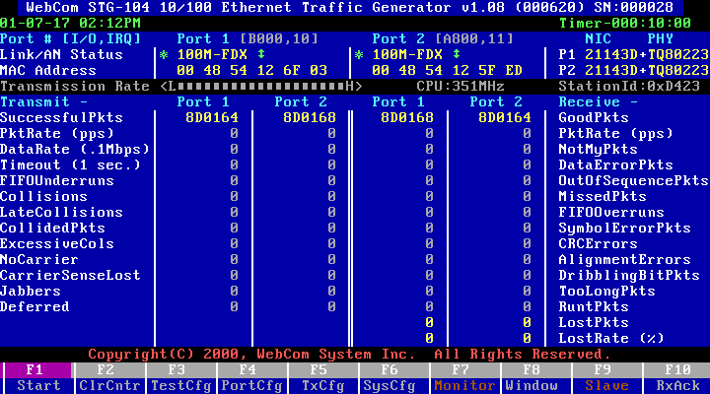
UTP 100MB Full Duplex Mode

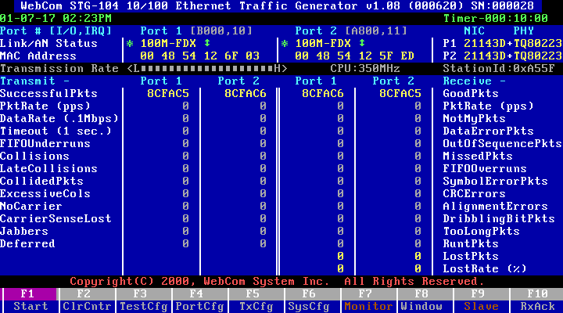

UTP 100MB Half Duplex Mode
(Set duplex mode for fiber port to half duplex though sliding switch)

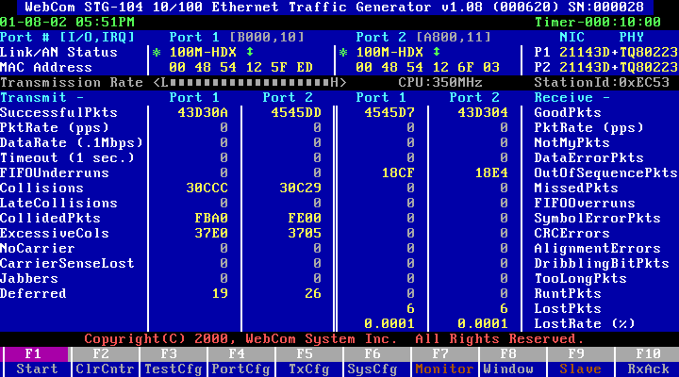
UTP 10MB Full Duplex Mode

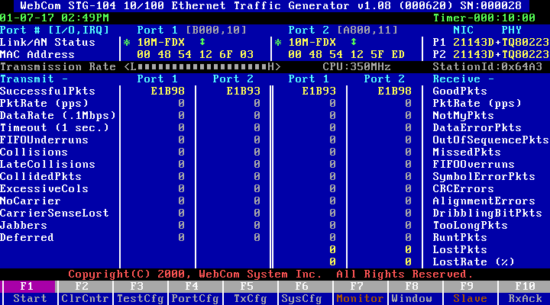

UTP 10MB Half Duplex Mode
(Set duplex mode for fiber port to half duplex though sliding switch)

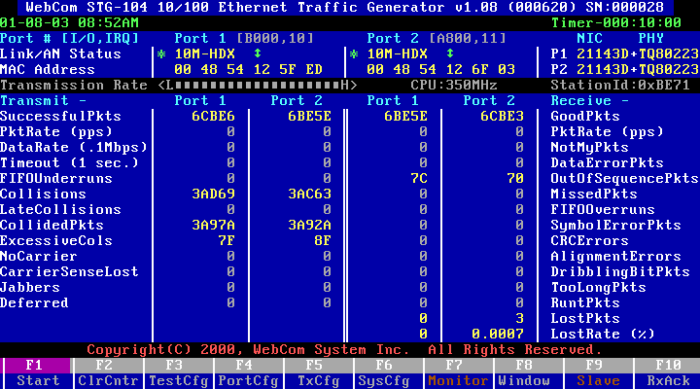
UTP 100MB Half and 10MB Half Mode
(Set duplex mode for fiber port to half duplex though sliding switch)

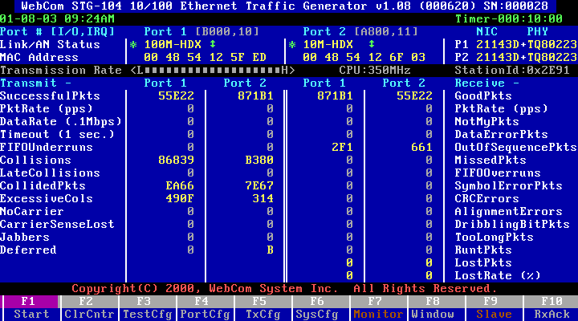

STP Auto Mode

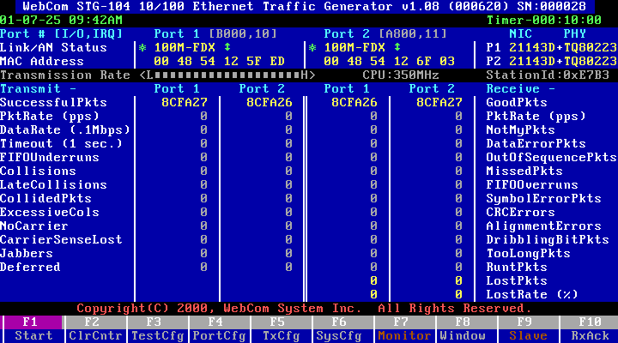
STP 100MB Full Duplex Mode

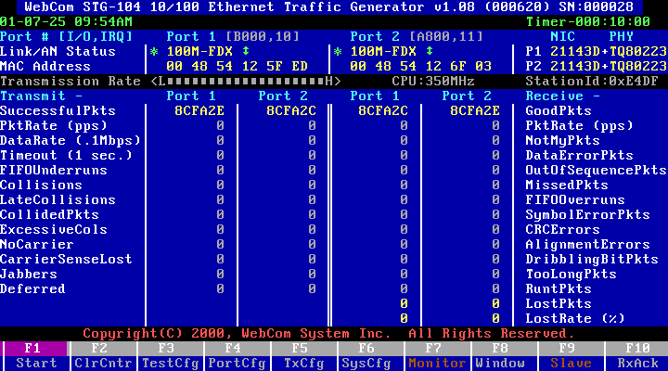

STP100MB Half Duplex Mode
(Set duplex mode for fiber port to half duplex though sliding switch)

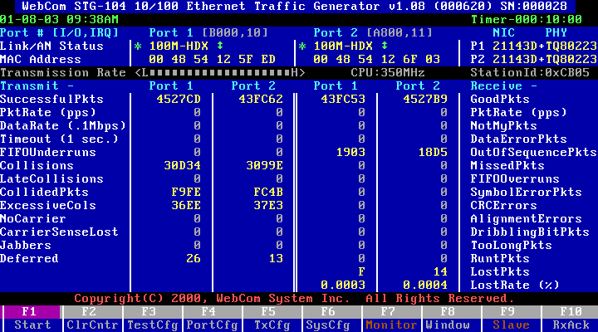
STP 10MB Full Duplex Mode

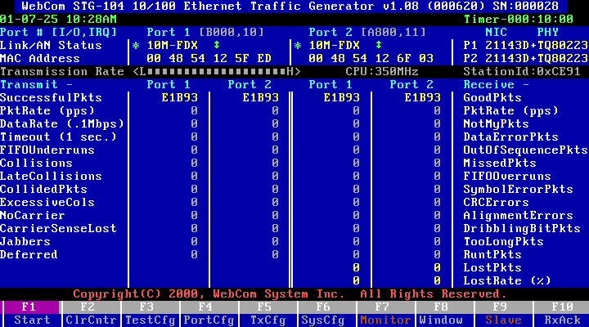

STP 10MB Half Duplex Mode
(Set duplex mode for fiber port to half duplex though sliding switch)

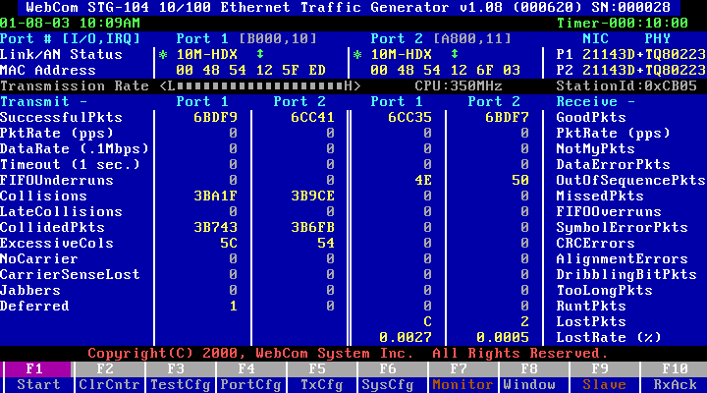
STP 100MB Half and 10MB Half Duplex Mode
(Set duplex mode for fiber port to half duplex though sliding switch)

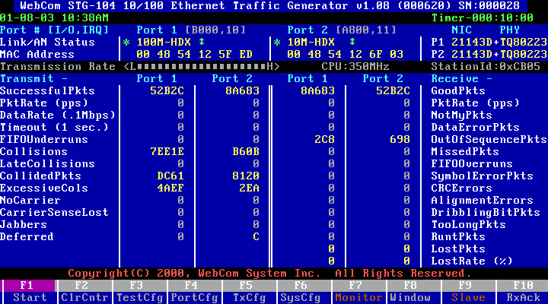

ITEM |  | OK/  FAIL | NOTE
SECTION 9: Advanced Switch Test.
. UTP 100MB Auto Mode | 
. UTP 100MB Full Duplex Mode | 
. UTP 100MB Half Duplex Mode | X
. UTP 10MB Full Duplex Mode | 
. UTP 10MB Half Duplex Mode | X
. UTP 100MB Half and 10MB Half Duplex Mode | 
. STP 100MB Auto Mode | 
. STP 100MB Full Duplex Mode | 
. STP 100MB Half Duplex Mode | X
. STP 10MB Full Duplex Mode | 
. STP 10MB Half Duplex Mode | X
. STP 100MB Half and 10MB Half Duplex Mode | 

3.1.10 Cable length test
Test Configuration : Changing the cables for different length between client and
DMC-300SC, and connect server via 62.5/125um multi-mode
fiber optic cable with 2Km.
Test Tools : NOVELL Endurnce.EXE
Test Object : Test the compatible ability with different Cable length.
Test procedure : Run Endurnce.EXE program in client with DMC-300SC
count for 10minutes.
Pass/Fail Criteria : Workstations work well/any connection hangs up.
ITEM |  | OK/  FAIL | NOTE
SECTION 10: Cable Length Test.
. 10 cm CAT5 Cable | ˇ
. 20 cm CAT5 Cable | ˇ
. 30 cm CAT5 Cable | ˇ
. 40 cm CAT5 Cable | ˇ
. 50 cm CAT5 Cable | ˇ
. 60 cm CAT5 Cable | ˇ
. 70 cm CAT5 Cable | ˇ
. 80 cm CAT5 Cable | ˇ
. 90 cm CAT5 Cable | ˇ
. 1 m CAT5 Cable | ˇ
. 2 m CAT5 Cable | ˇ
. 3 m CAT5 Cable | ˇ
. 4 m CAT5 Cable | ˇ
. 5 m CAT5 Cable | ˇ
. 6 m CAT5 Cable | ˇ
. 7 m CAT5 Cable | ˇ
. 8 m CAT5 Cable | ˇ
. 9 m CAT5 Cable | ˇ
. 10 m CAT5 Cable | ˇ
. 20 m CAT5 Cable | ˇ
. 30 m CAT5 Cable | ˇ
. 40 m CAT5 Cable | ˇ
. 50 m CAT5 Cable | ˇ
. 60 m CAT5 Cable | ˇ
. 70 m CAT5 Cable | ˇ
. 80 m CAT5 Cable | ˇ
. 90 m CAT5 Cable | ˇ
. 100 m CAT5 Cable | ˇ
. 105 m CAT5 Cable | ˇ

All Ports speed is 100MB Full Duplex Mode
(Cascade two DMC-300SC via 62.5/125um multi-mode fiber optic cable with 2Km)

SmartCounters | Events | Events
 | 01 SX-7410 | 02 SX-7410
Tx Frames | 10,000,000 | 10,000,000
Rx Frames | 9,999,877 | 9,999,976
Rx Bytes | 639,992,128 | 639,998,464
Rx Triggers | 9,999,877 | 9,999,976
Collisions | 0 | 0
CRC Errors | 0 | 0
Alignment Errors | 0 | 0
OverSize | 0 | 0
Frag/UnderSize | 0 | 0

All Ports speed is 100MB Half Duplex Mode
(Cascade two DMC-300SC via 62.5/125um multi-mode fiber optic cable with 2Km)
(Set duplex mode for fiber port to half duplex though sliding switch)

SmartCounters | Events | Events
 | 01 SX-7410 | 02 SX-7410
Tx Frames | 10,000,000 | 10,000,000
Rx Frames | 9,998,628 | 9,998,728
Rx Bytes | 640,342,102 | 640,355,671
Rx Triggers | 9,998,628 | 9,998,728
Collisions | 313,228 | 315,016
CRC Errors | 0 | 0
Alignment Errors | 0 | 0
OverSize | 0 | 0
Frag/UnderSize | 374,876 | 378,034

All Ports speed is 10MB Full Duplex Mode
(Cascade two DMC-300SC via 62.5/125um multi-mode fiber optic cable with 2Km)

SmartCounters | Events | Events
 | 01 SX-7410 | 02 SX-7410
Tx Frames | 10,000,000 | 10,000,000
Rx Frames | 10,000,000 | 10,000,000
Rx Bytes | 9,999,879 | 10,000,000
Rx Triggers | 639,992,256 | 640,000,000
Collisions | 9,999,879 | 10,000,000
CRC Errors | 0 | 0
Alignment Errors | 0 | 0
OverSize | 0 | 0
Frag/UnderSize | 0 | 0

All Ports speed is 10MB Half Duplex Mode
(Cascade two DMC-300SC via 62.5/125um multi-mode fiber optic cable with 2Km)
(Set duplex mode for fiber port to half duplex though sliding switch)

SmartCounters | Events | Events
 | 01 SX-7410 | 02 SX-7410
Tx Frames | 10,000,000 | 10,000,000
Rx Frames | 9,941,607 | 9,942,069
Rx Bytes | 636,815,049 | 636,843,809
Rx Triggers | 9,941,607 | 9,942,069
Collisions | 317,217 | 317,021
CRC Errors | 0 | 0
Alignment Errors | 0 | 0
OverSize | 0 | 0
Frag/UnderSize | 430,548 | 430,181

 |  |  |  | Throughput Test
 |  |  | Test duration (sec): | 10 |  |  | Number of pairs: | 1
 |  |  | Minimum frame size (byte): | 64 |  |  | Initial rate (%): | 100.00
 |  |  | Maximum frame size (byte): | 1518 |  |  | Step rate (%): | None
 |  |  | Step frame size (byte): | Custom |  |  | Resolution rate (%): | 1.00
** Measured on one receiving card only |  |  |  |  |  |  | Mode: | Uni-directional
Frame Size | Passed Rate(%) | (01,01,01) to (02,08,01) (pks/sec) | Total
 |  | 100M -100M
64 | 100.00 | 148810 | 148810
128 | 100.00 | 84459 | 84459
256 | 100.00 | 45290 | 45290
512 | 100.00 | 23496 | 23496
1024 | 100.00 | 11973 | 11973
1280 | 100.00 | 9615 | 9615
1518 | 100.00 | 8127 | 8127

( CT: Cut Through (or FIFO), S&F: Store & Forward (or LIFO))
 |  |  |  | Latency Test
 |  |  | Test duration (sec): | 10 |  |  | Number of pairs: | 1
 |  |  | Minimum frame size (byte): | 64 |  |  | Initial rate (%): | 100.00
 |  |  | Maximum frame size (byte): | 1518 |  |  | Step rate (%): | 10.00
 |  |  | Step frame size (byte): | Custom |  |  | Resolution rate (%): | None
** Measured on one receiving card only |  |  |  |  |  |  | Mode: | Uni-directional
Frame Size | Rate Tested(%) | (01,01,01) to (02,08,01) (us)-CT | Average (CT) | (01,01,01) to (02,08,01) (us)-S&F | Average (S&F)
 |  | 100M -100M |  | 100M -100M
64 | 100.00 | 19.0 | 19.0 | 13.9 | 13.9
128 | 100.00 | 24.5 | 24.5 | 14.3 | 14.3
256 | 100.00 | 34.8 | 34.8 | 14.4 | 14.4
512 | 100.00 | 54.7 | 54.7 | 13.8 | 13.8
1024 | 100.00 | 96.3 | 96.3 | 14.4 | 14.4
1280 | 100.00 | 116.6 | 116.6 | 14.2 | 14.2
1518 | 100.00 | 135.7 | 135.7 | 14.3 | 14.3

 |  |  |  | Packet Loss Test
 |  |  | Test duration (sec): | 10 |  |  | Number of pairs: | 1
 |  |  | Minimum frame size (byte): | 64 |  |  | Initial rate (%): | 100.00
 |  |  | Maximum frame size (byte): | 1518 |  |  | Step rate (%): | 10.00
 |  |  | Step frame size (byte): | Custom |  |  | Resolution rate (%): | None
 |  |  |  |  |  |  | Mode: | Uni-directional
Frame Size | Rate Tested(%) | (01,01,01) to (02,08,01) (%) | Average
 |  | 100M -100M
64 | 100.00 | 0.000 | 0.000
128 | 100.00 | 0.000 | 0.000
256 | 100.00 | 0.000 | 0.000
512 | 100.00 | 0.000 | 0.000
1024 | 100.00 | 0.000 | 0.000
1280 | 100.00 | 0.000 | 0.000
1518 | 100.00 | 0.000 | 0.000

 |  |  |  | Back to Back Test
 |  |  | Test duration (sec): | 10 |  |  | Number of pairs: | 1
 |  |  | Minimum frame size (byte): | 64 |  |  | Initial rate (%): | 100.00
 |  |  | Maximum frame size (byte): | 1280 |  |  | Step rate (%): | 10.00
 |  |  | Step frame size (byte): | Custom |  |  | Resolution rate (%): | None
 |  |  |  |  |  |  | Mode: | Uni-directional
Frame Size | Rate Tested(%) | (01,01,01) to (02,08,01) Burst Size (frames) | Total
 |  | 100M -100M
64 | 100.00 | 1488100 | 1488100
128 | 100.00 | 844590 | 844590
256 | 100.00 | 452900 | 452900
512 | 100.00 | 234960 | 234960
1024 | 100.00 | 119730 | 119730
1280 | 100.00 | 96150 | 96150
1518 | 100.00 | 81270 | 81270

PkSize | Hub | Slot | Port | Gap | Rate | Burst | RcvPkt | XmtPkt | Collision | RcvTrig | RcvByte | CRC | Align | Oversize | Undersize | XmtTime
Trial: 1 Repetition: 1 Frame Size: 64 Percent Rate:100.00 Duration: 10 sec.
64 | 1 | 1 | 1 | 96 | 148810 | 1488095 | 0 | 1488095 | 0 | 0 | 100000472 | 0 | 0 | 0 | 0 | 100000476
64 | 2 | 8 | 1 | 96 | 148810 | 1488095 | 1488095 | 0 | 0 | 1488095 | 95238080 | 0 | 0 | 0 | 0
Trial: 1 Repetition: 1 Frame Size: 128 Percent Rate:100.00 Duration: 10 sec.
128 | 1 | 1 | 1 | 96 | 84459 | 844594 | 0 | 844594 | 0 | 0 | 100000367 | 0 | 0 | 0 | 0 | 100000371
128 | 2 | 8 | 1 | 96 | 84459 | 844594 | 844594 | 0 | 0 | 844594 | 108108032 | 0 | 0 | 0 | 0
Trial: 1 Repetition: 1 Frame Size: 256 Percent Rate:100.00 Duration: 10 sec.
256 | 1 | 1 | 1 | 96 | 45290 | 452898 | 0 | 452898 | 0 | 0 | 100000213 | 0 | 0 | 0 | 0 | 100000217
256 | 2 | 8 | 1 | 96 | 45290 | 452898 | 452898 | 0 | 0 | 452898 | 115941888 | 0 | 0 | 0 | 0
Trial: 1 Repetition: 1 Frame Size: 512 Percent Rate:100.00 Duration: 10 sec.
512 | 1 | 1 | 1 | 96 | 23496 | 234962 | 0 | 234962 | 0 | 0 | 99999957 | 0 | 0 | 0 | 0 | 99999961
512 | 2 | 8 | 1 | 96 | 23496 | 234962 | 234962 | 0 | 0 | 234962 | 120300544 | 0 | 0 | 0 | 0
Trial: 1 Repetition: 1 Frame Size: 1024 Percent Rate:100.00 Duration: 10 sec.
1024 | 1 | 1 | 1 | 96 | 11973 | 119731 | 0 | 119731 | 0 | 0 | 99999052 | 0 | 0 | 0 | 0 | 99999056
1024 | 2 | 8 | 1 | 96 | 11973 | 119731 | 119731 | 0 | 0 | 119731 | 122604544 | 0 | 0 | 0 | 0
Trial: 1 Repetition: 1 Frame Size: 1280 Percent Rate:100.00 Duration: 10 sec.
1280 | 1 | 1 | 1 | 96 | 9615 | 96153 | 0 | 96153 | 0 | 0 | 99998635 | 0 | 0 | 0 | 0 | 99998639
1280 | 2 | 8 | 1 | 96 | 9615 | 96153 | 96153 | 0 | 0 | 96153 | 123075840 | 0 | 0 | 0 | 0
Trial: 1 Repetition: 1 Frame Size: 1518 Percent Rate:100.00 Duration: 10 sec.
1518 | 1 | 1 | 1 | 96 | 8127 | 81274 | 0 | 81274 | 0 | 0 | 99998855 | 0 | 0 | 0 | 0 | 99998859
1518 | 2 | 8 | 1 | 96 | 8127 | 81274 | 81274 | 0 | 0 | 81274 | 123373932 | 0 | 0 | 0 | 0
Trial: 1 Repetition: 1 Frame Size: 64 Percent Rate:100.00 Duration: 10 sec.
64 | 1 | 1 | 1 | 96 | 148810 | 1488095 | 0 | 1488095 | 0 | 0 | 50000254 | 0 | 0 | 0 | 0 | 50000258
64 | 2 | 8 | 1 | 96 | 148810 | 1488095 | 1488095 | 0 | 0 | 1 | 50000447 | 0 | 0 | 0 | 0 | 50000448
Trial: 1 Repetition: 1 Frame Size: 128 Percent Rate:100.00 Duration: 10 sec.
128 | 1 | 1 | 1 | 96 | 84459 | 844594 | 0 | 844594 | 0 | 0 | 50000261 | 0 | 0 | 0 | 0 | 50000265
128 | 2 | 8 | 1 | 96 | 84459 | 844594 | 844594 | 0 | 0 | 1 | 50000509 | 0 | 0 | 0 | 0 | 50000510
Trial: 1 Repetition: 1 Frame Size: 256 Percent Rate:100.00 Duration: 10 sec.
256 | 1 | 1 | 1 | 96 | 45290 | 452898 | 0 | 452898 | 0 | 0 | 50000235 | 0 | 0 | 0 | 0 | 50000239
256 | 2 | 8 | 1 | 96 | 45290 | 452898 | 452898 | 0 | 0 | 1 | 50000586 | 0 | 0 | 0 | 0 | 50000587
Trial: 1 Repetition: 1 Frame Size: 512 Percent Rate:100.00 Duration: 10 sec.
512 | 1 | 1 | 1 | 96 | 23496 | 234962 | 0 | 234962 | 0 | 0 | 50000210 | 0 | 0 | 0 | 0 | 50000214
512 | 2 | 8 | 1 | 96 | 23496 | 234962 | 234962 | 0 | 0 | 1 | 50000760 | 0 | 0 | 0 | 0 | 50000761
Trial: 1 Repetition: 1 Frame Size: 1024 Percent Rate:100.00 Duration: 10 sec.
1024 | 1 | 1 | 1 | 96 | 11973 | 119731 | 0 | 119731 | 0 | 0 | 49999544 | 0 | 0 | 0 | 0 | 49999548
1024 | 2 | 8 | 1 | 96 | 11973 | 119731 | 119731 | 0 | 0 | 1 | 50000510 | 0 | 0 | 0 | 0 | 50000511
Trial: 1 Repetition: 1 Frame Size: 1280 Percent Rate:100.00 Duration: 10 sec.
1280 | 1 | 1 | 1 | 96 | 9615 | 96153 | 0 | 96153 | 0 | 0 | 49999336 | 0 | 0 | 0 | 0 | 49999340
1280 | 2 | 8 | 1 | 96 | 9615 | 96153 | 96153 | 0 | 0 | 1 | 50000505 | 0 | 0 | 0 | 0 | 50000506
Trial: 1 Repetition: 1 Frame Size: 1518 Percent Rate:100.00 Duration: 10 sec.
1518 | 1 | 1 | 1 | 96 | 8127 | 81274 | 0 | 81274 | 0 | 0 | 50000061 | 0 | 0 | 0 | 0 | 50000065
1518 | 2 | 8 | 1 | 96 | 8127 | 81274 | 81274 | 0 | 0 | 1 | 50001421 | 0 | 0 | 0 | 0 | 50001422
Trial: 1 Repetition: 1 Frame Size: 64 Percent Rate:100.00 Duration: 10 sec.
64 | 1 | 1 | 1 | 96 | 148810 | 1488095 | 0 | 1488095 | 0 | 0 | 0 | 0 | 0 | 0 | 0
64 | 2 | 8 | 1 | 96 | 148810 | 1488095 | 1488095 | 0 | 0 | 1488095 | 95238080 | 0 | 0 | 0 | 0
Trial: 1 Repetition: 1 Frame Size: 128 Percent Rate:100.00 Duration: 10 sec.
128 | 1 | 1 | 1 | 96 | 84459 | 844594 | 0 | 844594 | 0 | 0 | 0 | 0 | 0 | 0 | 0
128 | 2 | 8 | 1 | 96 | 84459 | 844594 | 844594 | 0 | 0 | 844594 | 108108032 | 0 | 0 | 0 | 0
Trial: 1 Repetition: 1 Frame Size: 256 Percent Rate:100.00 Duration: 10 sec.
256 | 1 | 1 | 1 | 96 | 45290 | 452898 | 0 | 452898 | 0 | 0 | 0 | 0 | 0 | 0 | 0
256 | 2 | 8 | 1 | 96 | 45290 | 452898 | 452898 | 0 | 0 | 452898 | 115941888 | 0 | 0 | 0 | 0
Trial: 1 Repetition: 1 Frame Size: 512 Percent Rate:100.00 Duration: 10 sec.
512 | 1 | 1 | 1 | 96 | 23496 | 234962 | 0 | 234962 | 0 | 0 | 0 | 0 | 0 | 0 | 0
512 | 2 | 8 | 1 | 96 | 23496 | 234962 | 234962 | 0 | 0 | 234962 | 120300544 | 0 | 0 | 0 | 0
Trial: 1 Repetition: 1 Frame Size: 1024 Percent Rate:100.00 Duration: 10 sec.
1024 | 1 | 1 | 1 | 96 | 11973 | 119731 | 0 | 119731 | 0 | 0 | 0 | 0 | 0 | 0 | 0
1024 | 2 | 8 | 1 | 96 | 11973 | 119731 | 119731 | 0 | 0 | 119731 | 122604544 | 0 | 0 | 0 | 0
Trial: 1 Repetition: 1 Frame Size: 1280 Percent Rate:100.00 Duration: 10 sec.
1280 | 1 | 1 | 1 | 96 | 9615 | 96153 | 0 | 96153 | 0 | 0 | 0 | 0 | 0 | 0 | 0
1280 | 2 | 8 | 1 | 96 | 9615 | 96153 | 96153 | 0 | 0 | 96153 | 123075840 | 0 | 0 | 0 | 0
Trial: 1 Repetition: 1 Frame Size: 1518 Percent Rate:100.00 Duration: 10 sec.
1518 | 1 | 1 | 1 | 96 | 8127 | 81274 | 0 | 81274 | 0 | 0 | 0 | 0 | 0 | 0 | 0
1518 | 2 | 8 | 1 | 96 | 8127 | 81274 | 81274 | 0 | 0 | 81274 | 123373932 | 0 | 0 | 0 | 0
Trial: 1 Repetition: 1 Frame Size: 64 Trial Duration(sec):10.00
64 | 1 | 1 | 1 | 96 | 1488100 | 1488100 | 0 | 1488100 | 0 | 0 | 0 | 0 | 0 | 0 | 0
64 | 2 | 8 | 1 | 96 | 1488100 | 1488100 | 1488100 | 0 | 0 | 1488100 | 95238400 | 0 | 0 | 0 | 0
Trial: 1 Repetition: 1 Frame Size: 128 Trial Duration(sec):10.00
128 | 1 | 1 | 1 | 96 | 844590 | 844590 | 0 | 844590 | 0 | 0 | 0 | 0 | 0 | 0 | 0
128 | 2 | 8 | 1 | 96 | 844590 | 844590 | 844590 | 0 | 0 | 844590 | 108107520 | 0 | 0 | 0 | 0
Trial: 1 Repetition: 1 Frame Size: 256 Trial Duration(sec):10.00
256 | 1 | 1 | 1 | 96 | 452900 | 452900 | 0 | 452900 | 0 | 0 | 0 | 0 | 0 | 0 | 0
256 | 2 | 8 | 1 | 96 | 452900 | 452900 | 452900 | 0 | 0 | 452900 | 115942400 | 0 | 0 | 0 | 0
Trial: 1 Repetition: 1 Frame Size: 512 Trial Duration(sec):10.00
512 | 1 | 1 | 1 | 96 | 234960 | 234960 | 0 | 234960 | 0 | 0 | 0 | 0 | 0 | 0 | 0
512 | 2 | 8 | 1 | 96 | 234960 | 234960 | 234960 | 0 | 0 | 234960 | 120299520 | 0 | 0 | 0 | 0
Trial: 1 Repetition: 1 Frame Size: 1024 Trial Duration(sec):10.00
1024 | 1 | 1 | 1 | 96 | 119730 | 119730 | 0 | 119730 | 0 | 0 | 0 | 0 | 0 | 0 | 0
1024 | 2 | 8 | 1 | 96 | 119730 | 119730 | 119730 | 0 | 0 | 119730 | 122603520 | 0 | 0 | 0 | 0
Trial: 1 Repetition: 1 Frame Size: 1280 Trial Duration(sec):10.00
1280 | 1 | 1 | 1 | 96 | 96150 | 96150 | 0 | 96150 | 0 | 0 | 0 | 0 | 0 | 0 | 0
1280 | 2 | 8 | 1 | 96 | 96150 | 96150 | 96150 | 0 | 0 | 96150 | 123072000 | 0 | 0 | 0 | 0
Trial: 1 Repetition: 1 Frame Size: 64 Trial Duration(sec):10.00
64 | 1 | 1 | 1 | 96 | 1488100 | 1488100 | 0 | 1488100 | 0 | 0 | 0 | 0 | 0 | 0 | 0
64 | 2 | 8 | 1 | 96 | 1488100 | 1488100 | 1488100 | 0 | 0 | 1488100 | 95238400 | 0 | 0 | 0 | 0

4.0 TESTING/VERIFICATION REPORT

4.1 TEST & VERIFICATON RESULT
- At the compatibility testing, using a 1M CAT5 cable to connect the DMC-300SC to the other device, and the chipset of device is Broadcom BCM5315, it fails to link.
- When tested by SmartWindow, we observe loss packets in full and half duplex mode
(100/10 Mbps),
- At the SmartBits Advanced Testing (X-Stream and Backbone Test), there
are loss packets.
4. When tested by STG104.EXE, we observe loss packets in half duplex mode
(100/10 Mbps),

4.2 EVALUATION & CONCLUSION

4.3 SUGGESTION

