Introduction
Thank you for purchasing the D-Link DU-CS USB to Serial Converter cable. The DU-CS is an intelligent, stackable expansion cable that connects to a PC USB port or USB Hub via the Universal Serial Bus (USB) port, providing one high-speed RS-232 serial port. This guide shows you how to install the device.

System Requirements
- PC compatible runs Windows 98, Windows 2000 or Windows ME
- Serial device compatible with virtual serial ports
- Open USB port

Box Includes
- D-Link DU-CS, the USB to Serial port converter cable
- Driver diskette
- User’s Guide

Features
Now you can connect your serial mode, mouse or other serial device to USB. Free up your serial port of other devices. Gain the speed and easy of USB.
- USB specification 1.1 compliant
- 1 Serial DB25 port
- 1 USB type ‘A’ port
- Free support

Installation of DU-CS under Win98
Note :
- Please install DU-CS at the procedure below.
- Plug the USB cable into the downstream port located in the back of your computer or USB HUB port.

Step A :

To install the DU-CS drivers.

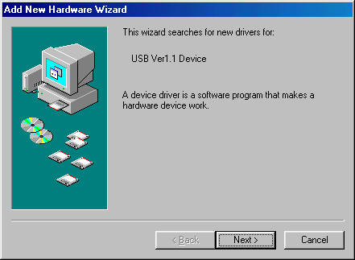
A1.

Please insert the driver disk into

floppy.

(2) Click “Next” to continue.
(Ref Figure A-1)

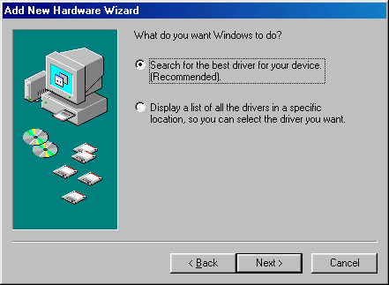
A2.
Click "Next" to initiate a search for the
best driver for your device.
(Ref Figure A-2)

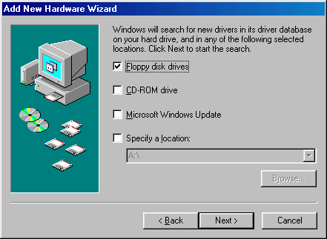
A3.
(1) Select “Floppy disk drives” or
“Specify a location”.
(2) Click "Next" to start and search.
(Ref Figure A-3)

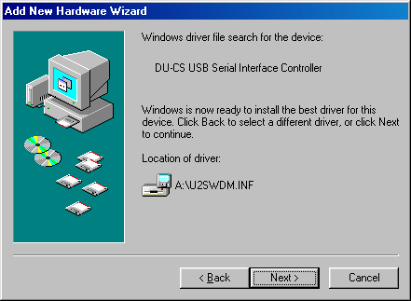
A4.

Click "Next" to continue.
(Ref Figure A-4)

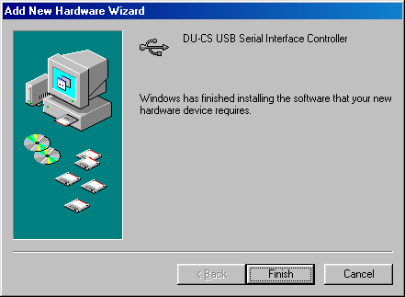
A5.
Click “Finish” , Windows has finished
installing the device.
(Ref Figure A-5)

Note:
- For RS232(serial) port setting:
Be sure to set "Serial on USB[COM3]"(or whichever the com port is available).
- You may switch RS232 mouse and other serial devices by replugging-in upstream
port(USB TypeB).

◆ USB device installed list as following
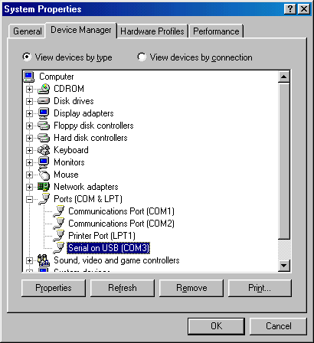
A)
If the “DU-CS COM port” device is
installed successfully, You can move
the cursor to “My computer”. Click the
mouse right bottom. It will show a dialog
then click “properties”, it will show a dialog”
System properties”. Then click “ Device
Manager”. Then select “ Ports (COM & LPT).
It will show a new direction “Serial on USB
[COM 3]”.

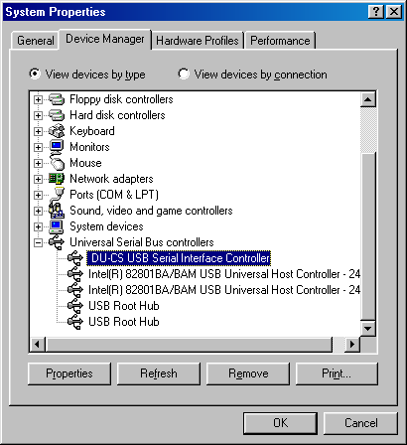
B)
Under the same window, you can select
“Universal Serial Bus controllers”, it will
show “DU-CS USB Serial Interface
Controller“.

◆ Installation Process of Serial Mouse
Please replug-in downstream port (USB Type A) after connecting the standard serial mouse device.

To install the serial mouse driver:
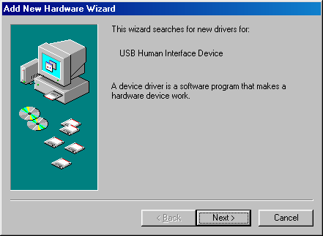
A)
Click “Next” to continue.

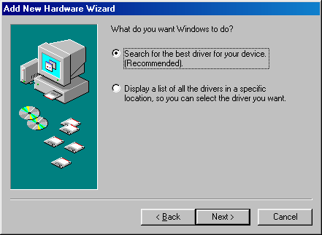
B)
Click “Next” to initiate a search for
the best driver for your device.

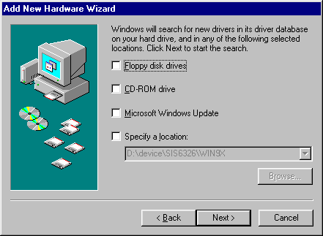
C)
Click “Next” to start and search.

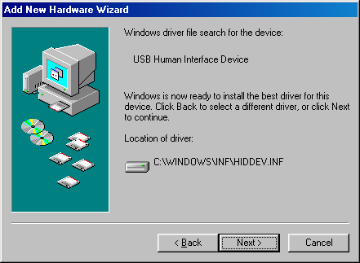
D)
Click “Next” to continue.

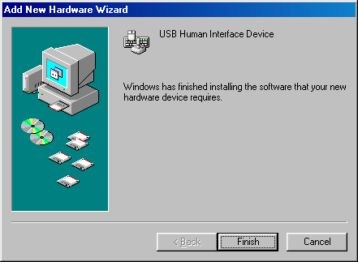
E)
Click “Finish”, Windows has finished
installing the device.

To make sure you have installed successfully, please move the cursor to My computer” → “Control Panel” → “System Properties” → “Device Manager” →”Human Interface devices”. It will show a new direction “USB Human Interface Devices”. And under the same window, you can select”Mouse”. It will show “HID-compliant mouse”.
A) B)
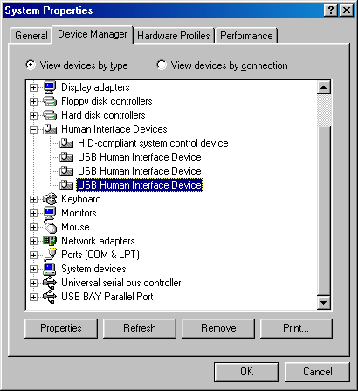
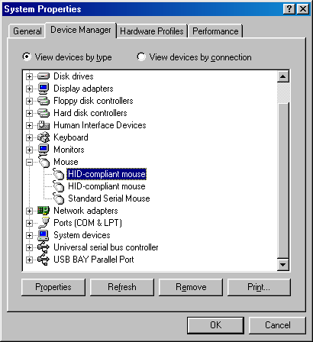

- Uninstallation
A)
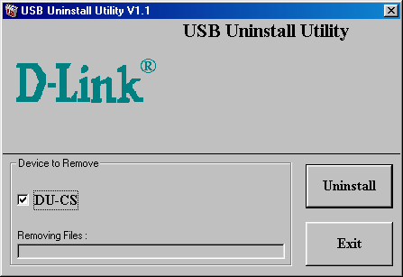
- Select “DU-CS”.
- Click “Uninstall” to uninstall drivers
of DU-CS.

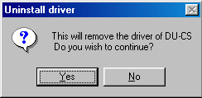
B)
If you wish to uninstall the driver,
please select “Yes” to continue.

C)
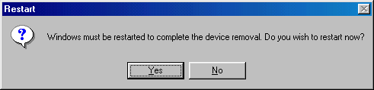
Please click “Yes” to restart the system
and complete the device’s removal.

Installation of DU-CS under Win2000
Note :
- The installation is divided into 2 steps. Please install DU-CS step by step from Step A-B.
- Plug the USB cable into the downstream port located in the back of your computer or USB HUB port.

Step A :

To install the DU-CS drivers.

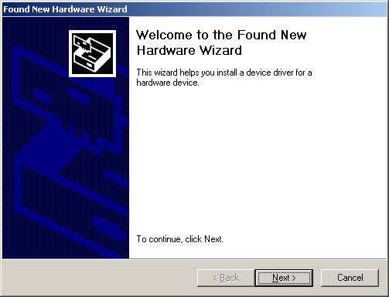
A1.
- Please insert the driver disk into
floppy.
- Click “Next” to continue.
(Ref Figure A-1)

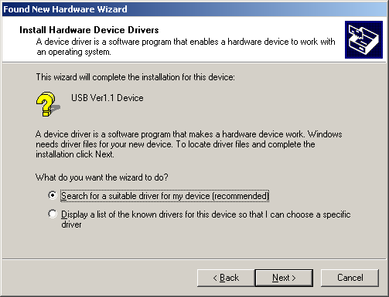
A2.
Click "Next" to initiate a search for the
best driver for your device.
(Ref Figure A-2)

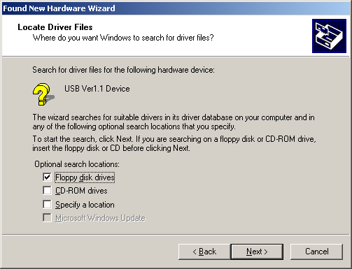
A3.
- Select “Floppy disk drives” or
“Specify a location”.
(2) Click "Next" to start and search.
(Ref Figure A-3)

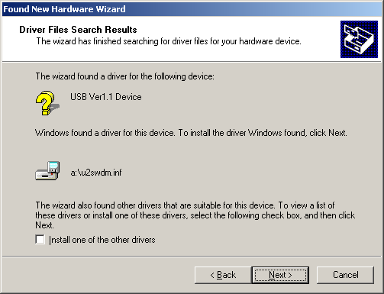
A4.
Click “Next” to continue.
(Ref Figure A-4)

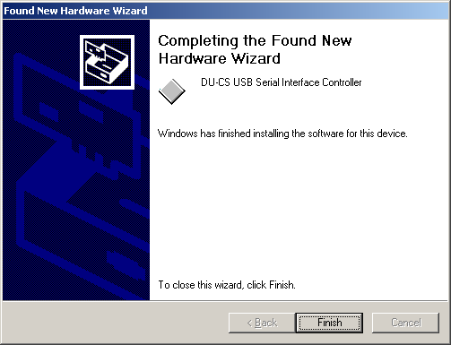
A5.

Click “Finish”, Windows has finished

installing the device.
(Ref Figure A-5)

Step B :
To install the driver of com port.

B1.
Click “Next” to continue.
(Ref Figure B-1)

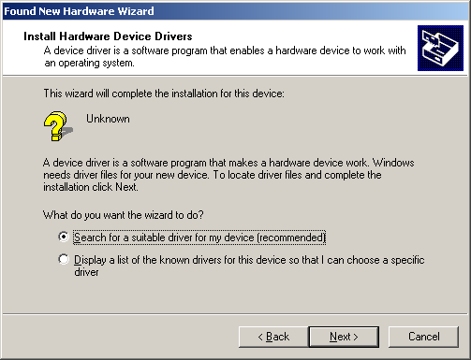
B2.
Click "Next" to initiate a search for the
best driver for your device.
(Ref Figure B-2)

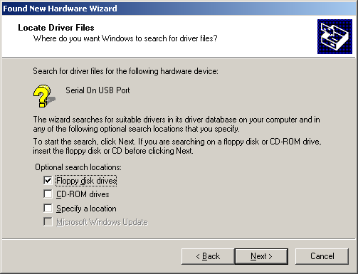
B3.
- Select “Floppy disk drives” or
“Specify a location”.
(2) Click "Next" to start and search.
(Ref Figure B-3)

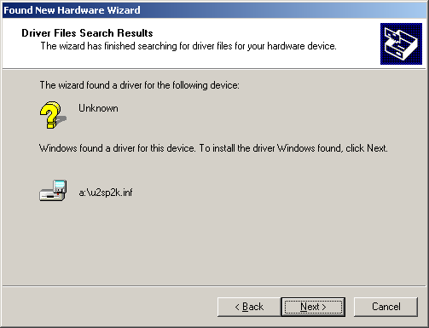
B4.
Click “Next” to continue.
(Ref Figure B-4)

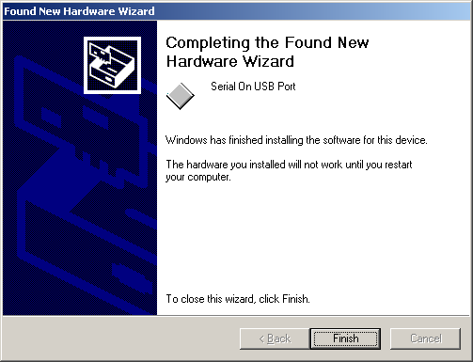
B5.

Click “Finish”, Windows has finished

installing the device.
(Ref Figure B-5)

◆ Click “Yes” to restart your computer, and complete the installation.
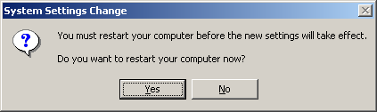

Note:
- For RS232(serial) port setting:
Be sure to set "Serial on USB[COM3]"(or whichever the com port is available).
- You may switch RS232 mouse and other serial devices by replugging-in upstream
port(USB TypeB).
◆ USB device installed list as following
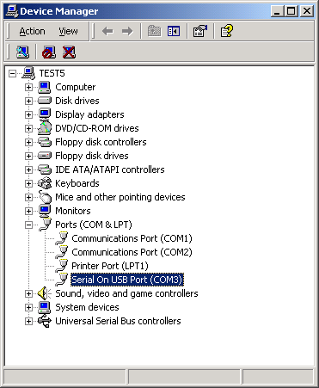
If the “DU-CS COM port” device is installed
successfully, you can move the cursor to
“My computer”. Click the mouse right
bottom. It will show a dialog then click
“properties”, it will show a dialog ”System
properties”. Then click “Hardware”, and then
click “Device Manager”. Then select “ Ports
(COM & LPT). It will show a new direction
“Serial on USB [COM 3]”.

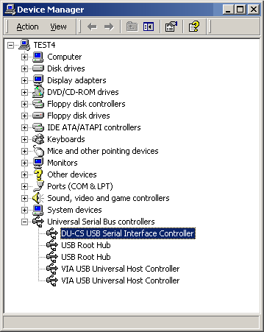
Under the same window, you can select
“Universal Serial Bus controllers”, it will
show “DU-CS USB Serial Interface
Controller“.

◆ Installation Process of Serial Mouse
Please replug-in downstream port (USB Type A) after connecting the standard serial mouse device. It will install the driver of standard serial mouse automatically.
To make sure you have installed successfully, please move the cursor to My computer” → “Control Panel” → “System Properties” → “Hardware” → “Device Manager” →”Human Interface devices”. It will show a new direction “USB Human Interface Devices”. And under the same window, you can select”Mouse”. It will show “HID-compliant mouse”.
A) B)
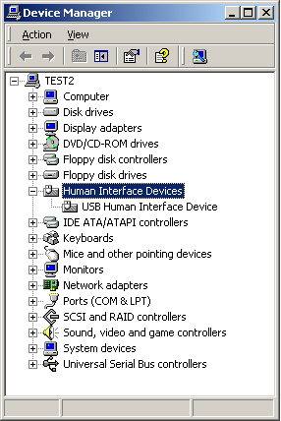
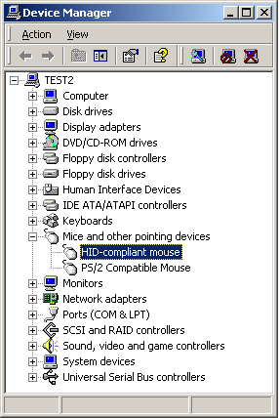

- Uninstallation
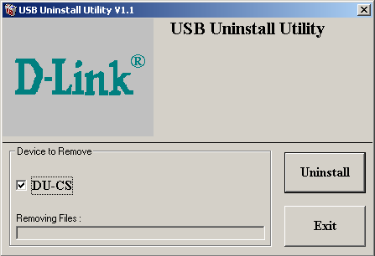
A)
- Select “DU-CS”.
- Click “Uninstall” to uninstall drivers
of DU-CS.

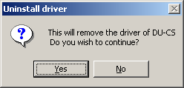
B)
If you wish to uninstall the driver,
please select “Yes” to continue.

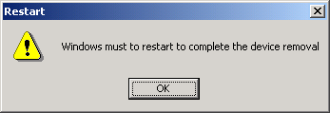
C)
Please click “OK” and restart the system
and complete the device’s removal.

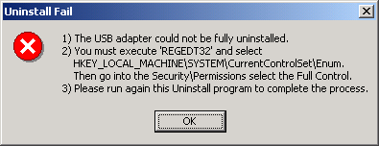
Note:
If it show “Uninstall Fail”, the USB
adapter could not be fully uninstalled.
Please execute “REGEDT32” and select
“HKEY_LOCAL_MACHINE\SYSTEM\
CurrentControlSet\Enum”. And then
go into the “Security\Permissions” of
the “Enum” select the “Full Control”.
Please run again this Uninstall program
to complete the process.
Installation of DU-CS under WinME
Note :
- Please install DU-CS at the procedure below:
- Plug the USB cable into the downstream port located in the back of your computer or USB HUB port.

Step A :

To install the DU-CS drivers.

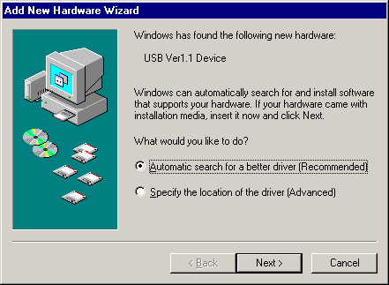
A1.
- Please insert the driver disk into
floppy.
(2) Click “Next” to continue.

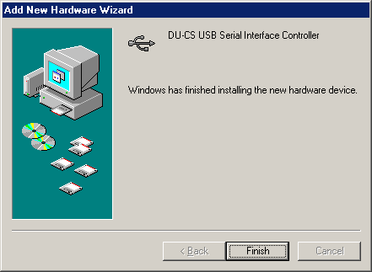
A2.

Click “Finish”, Windows has finished
installing the device.

Note:
- For RS232(serial) port setting:
Be sure to set "Serial on USB[COM3]"(or whichever the com port is available).
- You may switch RS232 mouse and other serial devices by replugging-in upstream

port(USB TypeB).

◆ USB device installed list as following
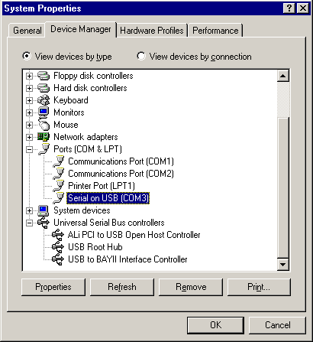
If the “DU-CS COM port” device is installed
successfully, you can move the cursor to
“My computer”. Click the mouse right bottom.
It will show a dialog then click properties, it
will show a dialog” System properties”. Then
click “ Device Manager”. Then select “ Ports
(COM & LPT). It will show a new direction
“Serial on USB [COM 3]”.

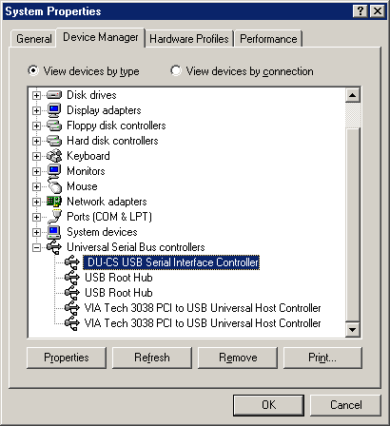
Under the same window, you can select
“Universal Serial Bus controllers”, it will
show “DU-CS USB Serial Interface
Controller“.

◆ Installation Process of Serial Mouse
Please replug-in downstream port (USB Type A) after connecting the standard serial mouse device. It will install the driver of standard serial mouse automatically.
To make sure you have installed successfully, please move the cursor to My computer” → “Control Panel” → “System Properties” → “Device Manager” →”Human Interface devices”. It will show a new direction “USB Human Interface Devices”. And under the same window, you can select”Mouse”. It will show “HID-compliant mouse”.

A) B)
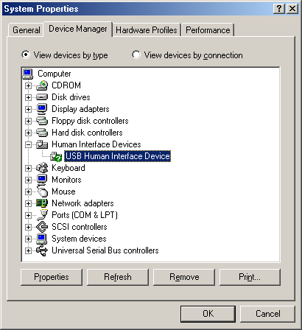
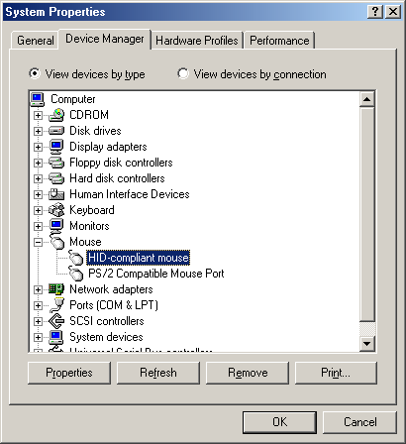

- Uninstallation
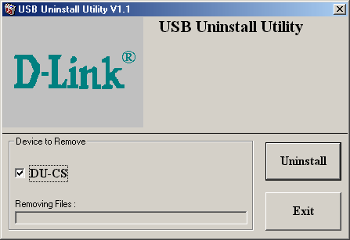
A)
- Select “DU-CS”
(2) Click “Uninstall” to uninstall drivers
of DU-CS.

B)
If you wish to uninstall the driver,
please select “Yes” to continue.

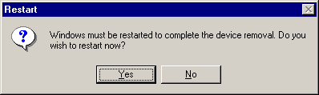
C)
Please click ”Yes” to restart the system
and complete the device’s removal.

