DU-H4S

Date: April 5, 2004

Product name: | USB 1.1 4port Slim Hub
Product Group & Type:
Revision: | A1
Available:
Picture: | 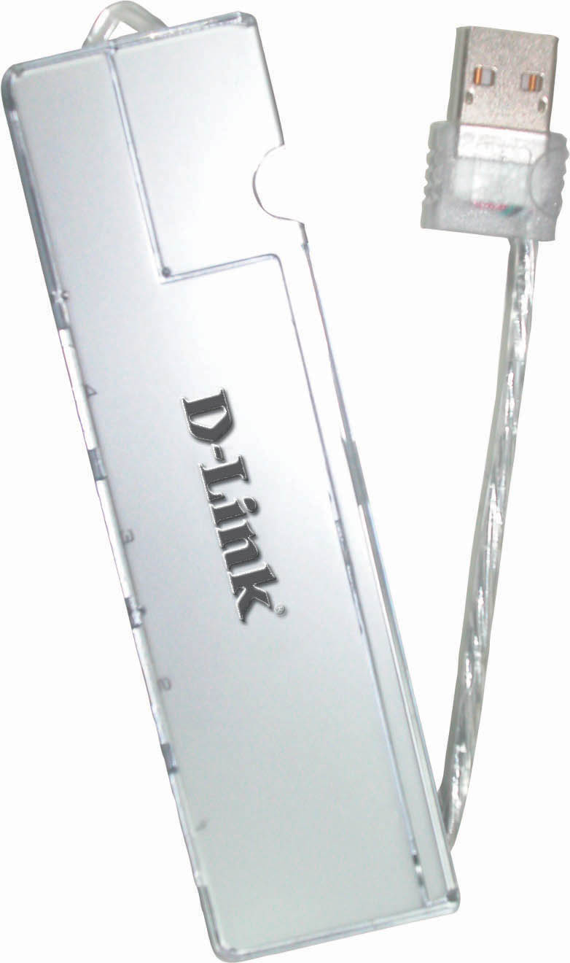
Why Sell This Product: | - Gain/maintain your USB market share.  - Target users: home PC, Mac users, SOHO users.  Selling Point  - This product is positioned as a low-cost USB device. It has an incredibly low cost per USB port. 4 ports packed in a very compact device.  - Slim, compact, beautiful design. This DU-H4S is priced slightly more than the comparable DU-H4L D-Link 4-port USB hub, because of its beautiful design.
Keyfeatures: | - USB 1.1 standard  - 4 Type A ports to connect to 4 USB devices  - Attached USB cable with Type A port to connect to computer or another USB hub  - Beautiful slim metal plastic case with built-in compartment for USB cable placement  - Mini pocket-sized, very lightweight  - No external power adapter required  - Easily fit into pocket or carrying case, or can be attached to briefcase through a string
Technical Details: | Standards  - USB Specification version 1.1  - OHCI  - UHCI  Supplied Current  4 ports support total 500mA from downstream port of USB host or upper level hub  Number of Ports  - 1 upstream USB port (USB Type A cable)  - 4 downstream USB ports (USB Type A connector)  Wiring Topology  Tiered Star  Connectivity Rules  - 5 cascaded hubs maximum  - 5 m maximum between each hub  - Up to 127 devices  Physical & Environmental  Dimensions  120 mm x 32 mm x 10.5 mm (device only)  Weight  32 grams (device only)  O.S. Support  - Windows 98, 98SE, ME, 2000, XP  - MacOS 8.9 and above  EMI Certifications  - FCC Class B  - CE Class B  - C-Tick
EMI/EMC Report | ☑FCC No. ☑ CE No. ◻ VCCI No.  ◻ CTR-21 No. ◻ C-Tick No. ◻ A-Tick No.  ◻ FDA No. ◻ R&TTE No. ◻ BSMI No.  ◻ Others
Safety | ◻ TUV No. ◻ UL No. ◻ CSA No.  ◻ Others
Packaging Style | ◻ Clamshell ◻ White Box ◻ Gift Box ◻ Bulk ☑ Others
Packaging Contents: | DU-H4S * 1
UPC Code:
  DUH4S…..A1 | 790069 26750 5
  TDUH4S….A1 | 790069 26790 1
Units Per Carton: | 50
Cartons Per Pallet: | Air: 90, Sea: 120
Dimensions and Weight: | Box: 210 x 100 x 12 mm, 0.057 kg  Carton: 308 x 220 x 235 mm, 3.8 kg  Pallet: (by Air) 1200 x 1100 x 1482 mm, 360 kg  (by Sea) 1200 x 1100 x 2090 mm, 470 kg  INTRASTAT weight: kg (Box)  Packing material weight (Box):  - Paper: kg  - Plastic: kg  - Mixed: kg

