ENGLISH

DU-R100

User’s Guide

Copyright Statement
ENGLISH

No part of this publication may be reproduced in any form or by any means or used to make any derivative such as translation, transformation, or adaptation without permission from D-Link Corporation / D-Link Systems Inc., as stipulated by the United States Copyright Act of 1976.

FCC Certifications

This equipment has been tested and found to comply with the limits for a Class B digital device, pursuant to Part 15 of the FCC Rules. These limits are designed to provide reasonable protection against harmful interference in a residential installation. This equipment generates, uses and can radiate radio frequency energy and, if not installed and used in accordance with the instructions, may cause harmful interference to radio communications. However, there is no guarantee that interference will not occur in a particular installation. If this equipment does cause harmful interference to radio or television reception, which can be determined by turning the equipment off and on, the user is encouraged to try to correct the interference by one or more of the following measures:

Reorient or relocate the receiving antenna.
ENGLISH

Increase the separation between the equipment and receiver.

Connect the equipment into an outlet on a circuit different from that to which the receiver is connected.

Consult the dealer or an experienced radio/TV technician for help.

Shielded interface cables must be used in order to comply with emission limits.

You are cautioned that changes or modifications not expressly approved by the party responsible for compliance could void your authority to operate the equipment.

This device complies with Part 15 of the FCC rules. Operation is subject to the following two conditions: (1) This device may not cause harmful interference, and (2) This device must accept any interference received, including interference that may cause undesired operation.

Contents
Chapter 1 Installing the DU-R100………..…...….....4
ENGLISH
1-1 Hardware installation……………....………...…4
1-2 Software Installation…………….…………..…..5
Chapter 2 Understanding the DU-R100 Menus…....6
Chapter 3 How to Preset your favorite stations…….10
3-1 Tuning…………………..………………….….10
3-2 Preset channel……………………...………….10
Chapter 4 How to use “Sleep” and “Wake up” functions…………………………………..13
4-1. Setting Sleep Time……………………………13
4-2. Setting Wake up time…………………………14
Chapter 5 Recording and playing…………….……...16
5-1. Specifying Wave Formats………………….….16
5-2. How to record into Wave File…………………17
5-3. Saving Wave Files…………………………….18
5-4. Preset the Recording…………………………..18
5-5. Opening a Wave File………………………….19
5-6. Playing Wave Files……………………………19
Chapter 6 Converting wave files to MP3……………21
6-1. Selecting the file………………………………21
6-2. Deleting MP3 files…………………………….23
Chapter 1 Installing the DU-R100
ENGLISH

1-1 Hardware installation
- Plug DU-R100 USB flat connector into the USB port of your PC. If the PC has a sound card, plug the DU-R100’s RCA cable into the existing LINE IN port of the sound card. If not, plug the RCA jack into any speakers. Note that the recording function is not available when running DU-R100 software in this way.
- The computer will detect DU-R100 and look for a driver. If a driver is not found, it will then prompt for one. At this time, make sure that your DU-R100 diskette is inserted into your computer floppy drive.
- The computer is now ready to install the DU-R100 driver from floppy the drive.

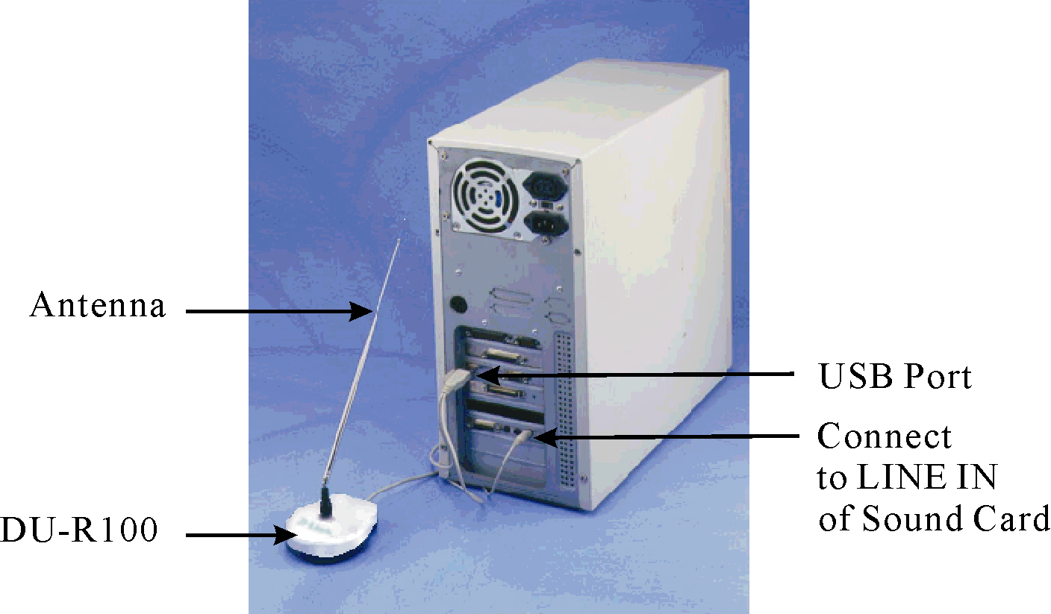
1-2 Software Installation
ENGLISH
The DU-R100 comes with user applications for Windows 98. The following installation installs the application into your PC.

Installing under Windows 98

- Insert the DU-R100 Utility diskette into drive A or B.
- Click on My Computer icon.
- Select Floppy(A: ) (where A: is your selected diskette drive)
- Double click on Setup icon.
- After the Setup program of the DU-R100 pops up, simply follow the instructions on the screen to complete the installation.

Chapter 2 Understanding the DU-R100 Menus
ENGLISH
The DU-R100 has three: WaveFile, Options and Help. The menus are text sensitive and can be activated easily by mouse clicks.

WaveFile Menu
The WaveFile Menu contains the following commands:

New | Creates a new wave file
Open | Loads an existing wave file
Save | Saves a current wave file
Save As | Saves the wave file under a new name
Wave to MP3 utility | Converts the wave file to an MP3 file
Exit | Quits the DU-R100

Options Menu
The following commands of the Options menu allow you to change FM DU-R100’s default settings:

Record Settings | Sets the default record settings
Volume Controllers Setting | Controls the playback volume of the wave file
Show Station Name | Shows the Station Name on the Preset Channel rather than the frequency
Sleep Function | Enables/disables the Sleep Function
Wake Up Function | Enables/disables the Wake Up Function
24-Hour Clock Format | Displays either 24 hour time or AM/PM  ENGLISH
LR Volume Indicator | Displays the sound indicator function
Turn off Radio On Exit | Radio will stop playing once DU-R100 application is closed

Help Menu

Contents | Explains the key functions of the main panels
About | Shows the version and copyright of the DU-R100

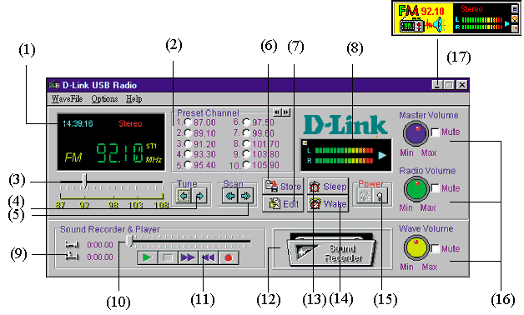

(1) Display box | ENGLISH  Displays current station, time and radio station
(2) Preset Channel | Presets your favorite Radio stations for up to 200 channels
(3) Frequency Slider | Allows you to select the desired radio station by dragging the mouse.
(4) Tuner | Allows you to adjust frequency at 0.05 MHz intervals.
(5) Scan | Scans radio stations by clicking mouse button. Click it again to stop scanning.
(6) Store | Stores the preset channel and station name.
(7) Edit | Edits the preset channels and station names.
(8) LED display | Shows sound intensity of both left and right speakers. Clicking on this display will change to wave format.
(9) Length of the recorded file | Displays the length of the recorded file and current location of the recorded file.
(10) Sound Recorder Indictor | Acts as FF/Rewind by dragging slider
(11) Recorder, player control bar | Includes Play, Rewind, FF, Stop and Record functions.
(12) Animated tape recorder | Revolves while you are using the recorder. You can view free hard disk space by clicking the left mouse button.
(13)Sleep | Sets sleep time. (turns off power)
(14)Wake | Sets wake up time. (turns on power)
(15)Power on/off | Turns on/off power.
(16)Volume controls | Master volume controls speaker volume. Radio volume controls recording and output volume. Wave volume controls playback volume.
(17)Stay On Top | Toggles small window as the topmost window. You can move this small window anywhere on your desktop by dragging it with the left mouse button.

Chapter 3 How to Preset your favorite stations
ENGLISH

3-1 Tuning:

There are two ways to select your favorite programs -

3-1-1 Locate your favorite station by clicking the scan button . Click on
Tune button to fine tune until “stereo” appears on the LED display.

3-1-2 Hold down the left mouse button and drag to your favorite station.
Click once to fine tune..

3-2 Preset channel
Allows you to preset and customize your favorite programs by using their names or the frequency. 200 channels (20 groups) are available. The following explains ways to preset up to 200 channels.

3-2-1. To preset a channel with station name:

1. Select a station.
- Click on Store button . Store Preset Frequency and Station Name dialog box appears.
- Enter the Channel Number and Station Name
4. Click OK .
ENGLISH

E.g. To set channel 3 to frequency 100.10MHz and Station Name ICRT. Set Channel Number 3 and enter “ICRT”. Then click OK..
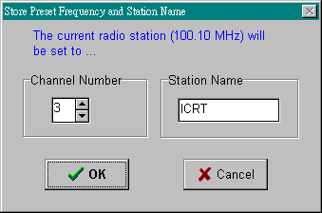

3-2-2 Editing preset channels
- Click on Edit button and edit preset channel frequency and their station names.

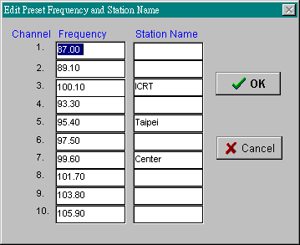
ENGLISH

2.Set the Channel Numbers and enter the desired Station Names.
3.Click on OK to confirm changes.

Chapter 4 How to use “Sleep” and “Wake up” functions
ENGLISH
DU-R100 provide “Sleep” and “Wake up” functions to save time and catch up with your favorite programs,.

4-1. Setting Sleep Time

To set Sleep time:
1.Choose “Sleep Function“ from the Options menu.
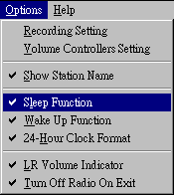

2. Click on the Sleep button . The Set Sleep Time dialog box appears as follows:

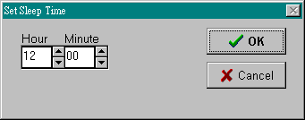
ENGLISH

- Set the time.
- Click on OK to confirm the setting.

The radio will turn off automatically at the selected sleep time.

4-2. Setting Wake up time

To set the Wake up time

- Choose “Wake Up Function Enabled “ from the Options menu.
- Click on the Wake button , The Set Wake Up Time dialog box appears as follows:

- Set the Hour and Minute dials to your wake up time.
ENGLISH
- Click on OK to confirm the setting

The radio turns off automatically at the selected wake up time. You can also set recording time by using this function. (Please refer to Chapter 5, Section 4).

 IMPORTANT: The Sleep and Wake Up functions are only available when a PC is turned on and this program is in use.

Chapter 5 Recording and playing
ENGLISH

5-1. Specifying Wave Formats

Before recording a wave file, make sure the correct format of the file is specified. Wave format refers to the sound channel, Sampling Rate and Size of the file.

To specify the wave format:

- Select Record Setting in the Options menu and Choose Wave Format dialog box appears.

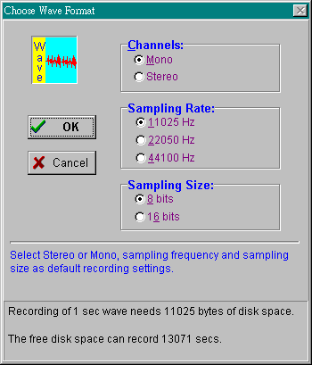

- Select the format for the wave file.
ENGLISH
Select Mono for one sound channel and Stereo for two sound channels.
Select 11025Hz for voice, 22050Hz for cassette and 44100Hz for CD quality recording.
Select 8 bits for cassette and 16 bits for CD sound quality.
- Choose OK.

There is a trade-off between the quality of a wave file and the amount of storage space required for the file. A wave file with better sound quality requires a larger storage space because of its high sampling rate. The message in the dialog box will inform you how much free disk space is available for recording.

5-2. How to record into Wave File

To record a wave file:

Click Record button. The animated tape recorder will revolve the length and current location of recorded file will be displayed.

To stop the recording, choose the Stop button . You can listen to the recorded file by pressing the Play button . If you would like to know the available free space on your hard disk, just click the Animated tape recorder and you will see the following figure:
ENGLISH

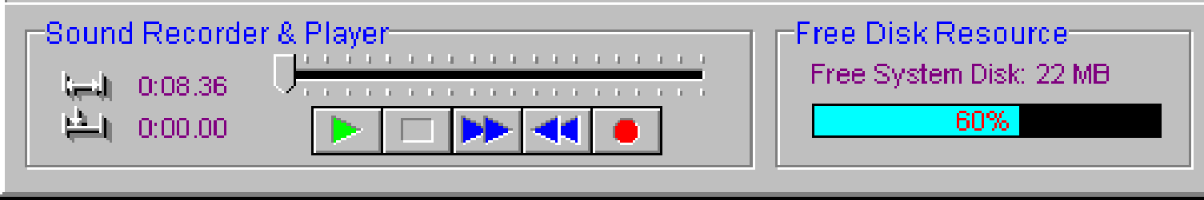
ENGLISH

Click on Free Disk Resource and Animated Tape Recorder will resume.

5-3. Saving Wave Files

To save a wave file:
- Choose Save or Save as from Wave File menu.
- Enter the name of the file and the path.
- Choose OK.

5-4. Preset the Recording

You can preset the recording by using the Sleep and Wake Up function.

To preset the recording :

- Click the Wake button , and the Set Wake Up Time dialog box appear:

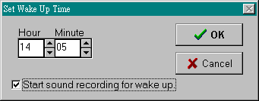

- Set the time and choose Start recording for wake up.
ENGLISH
- Choose OK.
- Click Sleep button ,set the time to turn off the power of the DU-R100 when the recording is completed.

DU-R100 will wake up, start and stop recording according to your procedure.

5-5. Opening a Wave File

To open a wave file:
- Select Open from the Wave File menu.
- Type or select the wave file you want to open.
- Choose OK.

5-6. Playing Wave Files

DU-R100 can play any kind of wave file.

To play a wave file :
- Open the wave file.
- Choose Play.

You can also drag slider to listen to the recorded wave file again.

To stop playing the wave file, choose Stop.

Chapter 6 Converting wave files to MP3

6-1. Selecting the file
ENGLISH
Wave files can be converted to MP3 files quickly and easily. In order to play the wave file you will need to download and install Real Player© or other applications that support MP3. You can download the application at www.real.com and www.winamp.com.
To convert a wave file to an MP3 file:
- Go to WaveFile and select Wave to MP3 utility.
- The Enhanced MP3 functions panel appears.

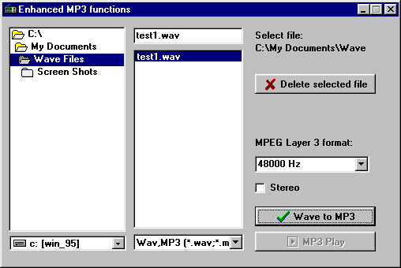

- Browse to the directory the wave file is in and select it the on panel to the right.
ENGLISH
- MPEB Layer 3 format gives you several ranges to choose from. Click on the down arrow and choose the sampling rate. 48000 Hz gives the best sound but uses the most memory.
- Click on the Wave to MP3 button to convert the file to MP3.
- Check the box marked Stereo for stereo sound.
- The MP3 Compressor panel gives you a status report on the file conversion.
- Click Pause to stop the conversion.

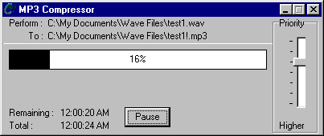
- Play the file using Real Player or other application to that supports MP3.

6-2. Deleting MP3 files
Delete MP3 files by selecting the files and clicking on the Delete selected file button on the Enhanced MP3 functions panel.

