DUB-AV300

Date: Nov 15, 2004

Product name: | USB 2.0 MPEG Video Grabber
Revision: | A1
Available:
Picture: | 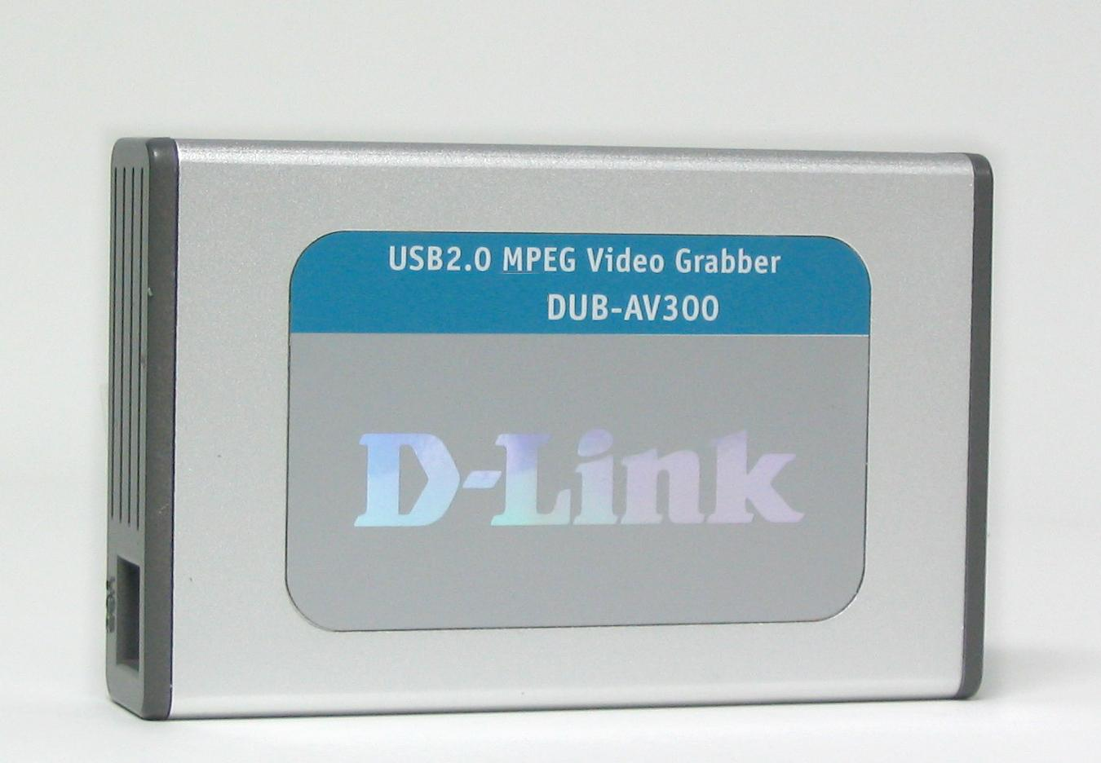
Why Sell This Product: | - Great add-on product for video cameras, VHS recorders: this little device allows users to use their analog cameras to carry out video conference, video mail, surveillance and periodic or long-time recording from their PC.  - Added audio function: this device captures audio from the analog device then synchronizes it with the video in the same digital file.  - Hardware-based MPEG1/2/4 encoder/decoder provides much higher speed than the current DUB-AV200.  - With lower cost and higher speed than the DUB-AV200, we will eventually phase out the DUB-AV200 and sell only the DUB-AV300.  Selling Points  - Supports more file formats: currently the DUB-AV200 supports only AVI, MPEG1, MPEG2 and MPEG4. The DUB-AV300 supports these formats, in addition it also supports the newer WMV, ASF and Divx formats.  - Software provided for MPEG movie creation.  - Software provided for burn-to-disc of recorded MPEG1/2/4 with VCD, SVCD & DVD quality.  - Fast USB 2.0 connection to PC.  - Compact size, high processing speed.
Key Features: | - Hardware-based high-speed analog to digital video conversion  - Video resolution up to 720 x 480 (NTSC), 720 x 576 (PAL)  - Snap shot: 720 x 480 still image  - Video bit rate: up to 10Mbps  - Audio bit rate: 48Kbps to 8Kbps  - Audio capture with audio/video synchronization function  - Capturing and recording formats: AVI, MPEG1/2/4, WMV, ASF, Divx  - Saturation, contrast, hue, brightness adjustment  - MPEG movie creation  - Direct burn-to-disc of recorded MPEG1/2/4 with VCD, SVCD & DVD quality (burner software included)  - MPEG movie creation with video editing software included  - Menu function control  - Fast USB 2.0 interface to PC
Technical Details: | System Requirements  - Pentium IV 2GHz or above  - 256MB RAM or more  - Microsoft Windows XP, 2000 with SP4  - Microsoft DirectX9 or higher  - One Available USB Port (USB 2.0 recommended)  - VGA card with 32MB RAM  - CD-R/W, DVD-R/W DVD+R/RW or DVD-RAM (for VCD, SVCD, DVD)  Output to PC  USB 2.0  Input From Camcorder, VCR, DVD  - S-Video (S-Terminal)  - RCA jacks (3 RCA jacks: 2 for audio, 1 for video)  Resolution  - DVD resolution quality: 720 x 480 @ 30fps (NTSC),  720 x 576 @ 25fps (PAL)  - SVCD resolution quality: 480 x 480 @ 30fps (NTSC),  480 x 576 @ 25fps (PAL)  - VCD resolution quality: 352 x 240 @ 30fps (NTSC),  352 x 288 @ 25fps (PAL)  - Snap shot: 720 x 480 still image  Physical & Environmental  Power Input  Powered directly from USB bus, no external power adapter required  Dimensions  111 (L) x 70 (W) x 22 (H) mm  Weight  100 grams  Operating Temperature  0 to 50 ℃  Storage Temperature  -10 to 60 ℃  Operating Humidity  10% to 90% non-condensing  Emission  - FCC Class B  - CE  Software & O.S. Driver Support  - MPEG Editor, DVD Creator software  (included with DUB-AV300)  - Microsoft Windows 2000 SP4, XP  Package Content  - DUB-AV300 Digital Capture  - USB 2.0 cable  - Audio/Video cable  - Quick Installation Guide  - CD (includes driver programs for Windows and Video Editing Software)
EMI/EMC Report | ☑FCC No. 04LE204FB ☑ CE No. 04LE204C ◻ VCCI No.  ◻ CTR-21 No. ☑ C-Tick No. ◻ A-Tick No.  ◻ FDA No. ◻ R&TTE No. ◻ BSMI No.  ◻ Others
Safety | ◻ TUV No. ◻ UL No. ◻ CSA No.  ◻ Others
Packaging Style | ◻ Clamshell ◻ White Box ☑ Gift Box ◻ Bulk ◻ White Box with D-Link Logo  ◻ Others
Packaging Contents: | DUB-AV300 USB2.0 Video Grabber  USB2.0 Cable  AV Cable  CD  QIG
UPC Code:
  IUBAV300..A1 | 790069 272042
  CUBAV300..A1 | 790069 272059
Units Per Carton: | 20
Cartons Per Pallet: | For USA Air:24, Sea: 30 | For WW Air:24, Sea:30
Dimensions and Weight: | Box:  mm,Others , 0.53 kg  Carton: 464 x 388 x 323 mm, 16 kg  Pallet: (by Air) 1220 x 1020 x 1510 mm, 294 kg (for USA)  1200 x 1100 x 1510 mm, 294 kg (for WW)  (by Sea) 1220 x 1020 x 1850 mm, 363 kg (for USA)  1200 x 1100 x 1850 mm, 363 kg (for WW)  INTRASTAT weight: 0.296 kg (Box)  Packing material weight (Box):  - Paper: 0.2354 kg  - Plastic: 0.0034 kg  - Mixed: 0.0046 kg

PMA 資料作業畫面
Product Class
Item Group
Sub Group
Intelligence
Tech.(Features)
Layer
Application




Q'ty

Interface
Net Interface
Port NO.
Interface
Net Interface
Port NO.
Interface
Net Interface
Port NO.
Interface
Net Interface
Port NO.

