DUB-CR200

Date: October 20, 2004

Product name: | USB 2.0 3 port Hub with card reader
Product Group & Type: | USB
Revision: | A1
Available:
Picture: | 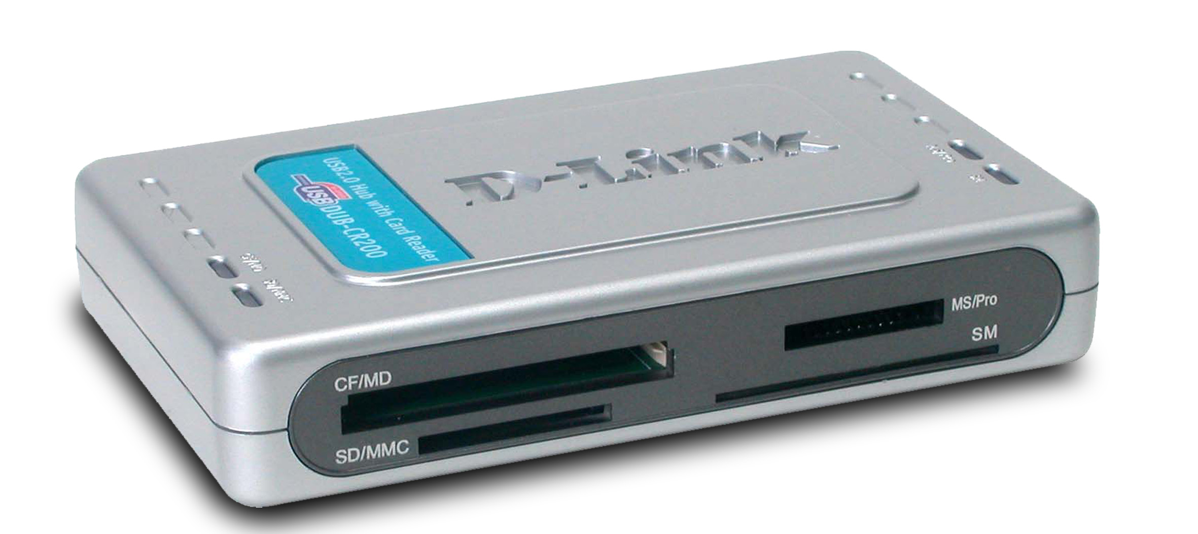
Why Sell This Product: | - Target users: PC users with digital cameras and USB devices like printers, external hard drives, etc.  - Make use of existing channels to sell additional consumer products.  Selling Points  - Good price/function.  - Compact, good look.
Key Features: | - Compatible with USB 2.0/1.1 specifications  - 4 sockets supporting SD/MMC, Memory Stick, MS-Pro, 3.3 V Smart Media, Compact Flash, IBM MicroDrive  - 3 USB 2.0 Type A ports for convenient connection to digital cameras and USB peripherals  - Supports Hot-Swap and Plug and Play function  - No additional device drive needed for Windows ME, 2000, XP  - LED indicators for data access  - Power supplied by USB bus power  - Allows data exchange among different sockets
Technical Details: | Connectors  - 1 USB 2.0 Type B female (to computer)  - 3 USB 2.0 Type A female (to USB-supported devices)  Slots  4 sockets supporting SD/MMC, Memory Stick, MS-Pro, 3.3 V Smart Media, Compact Flash, IBM MicroDrive  Power Supply  - DC input: 5VDC 2.5A  - AC input: through external power adapter  LED Indicators  - Power  - CF/MD  - SM  - MS/Pro  - SD/MMC  - 1, 2, 3 (for USB Type A ports)  Dimensions  118 x 72 x 21 mm (device only)  Weight  113 gram (device only)  Emission (EMI)  - FCC Class B  - CE Class B  Safety  UL  OS Support  - Microsoft Windows 98SE, ME, 2000, XP  - MacOS 9.x, 10.x and above  Box Includes  - DUB-CR200 Card Reader  - External power adapter  - USB 2.0 cable (1 meter)  - Quick Installation Guide  - CD
EMI/EMC Report | ☑FCC No. 40811403-D ☑ CE No. 40811403-E ◻ VCCI No.  ◻ CTR-21 No. ◻ C-Tick No. ◻ A-Tick No.  ◻ FDA No. ◻ R&TTE No. ◻ BSMI No.  ◻ Others
Safety | ◻ TUV No. ◻ UL No. ◻ CSA No.  ◻ Others
Packaging Style | ◻ Clamshell ◻ White Box ☑ Gift Box ◻ Bulk ◻ Others
Packaging Contents: | - DUB-CR200  - USB 2.0 cable in 6ft  - CD  - AC adapter(5V 2.5A)  - QIG
UPC Code:
  IUBCR200A.A1 | 790069 27177 9
  IUBCR200E.A1 | 790069 27178 6
  IUBCR200N.A1 | 790069 27179 3
  CUBCR200A.A1 | 790069 27180 9
  TUBCR200A.A1 | 790069 27207 3
  BUBCR200A.A1 | 790069 27220 2
Units Per Carton: | 20
Cartons Per Pallet: | Air: 18(for USA) , 24(for WW)  Sea: 30(for USA&WW)
Dimensions and Weight: | Box: 225 x 77.5 x 150 mm, 0.6 kg  Carton: 460 x 306 x 375 mm, 13 kg  Pallet: (by Air) 1200 x 1100 x 1590 mm, 327 kg (for WW)  1220 x 1020 x 1595 mm, 249 kg (for USA)  (by Sea) 1200 x 1100 x 2070 mm, 405 kg (for WW)  1220 x 1020 x 1885 mm, 405 kg (for USA)  INTRASTAT weight: kg (Box)  Packing material weight (Box):  - Paper: 0.2333 kg  - Plastic: 0.00244 kg  - Mixed: 0.0048 kg

