DUB-T210

Date: January 11, 2005

Product name: | USB 2.0 MPEG1/2/4 Encoder TV Tuner
Revision: | A1
Available: | M/Dec 2004
Picture: | 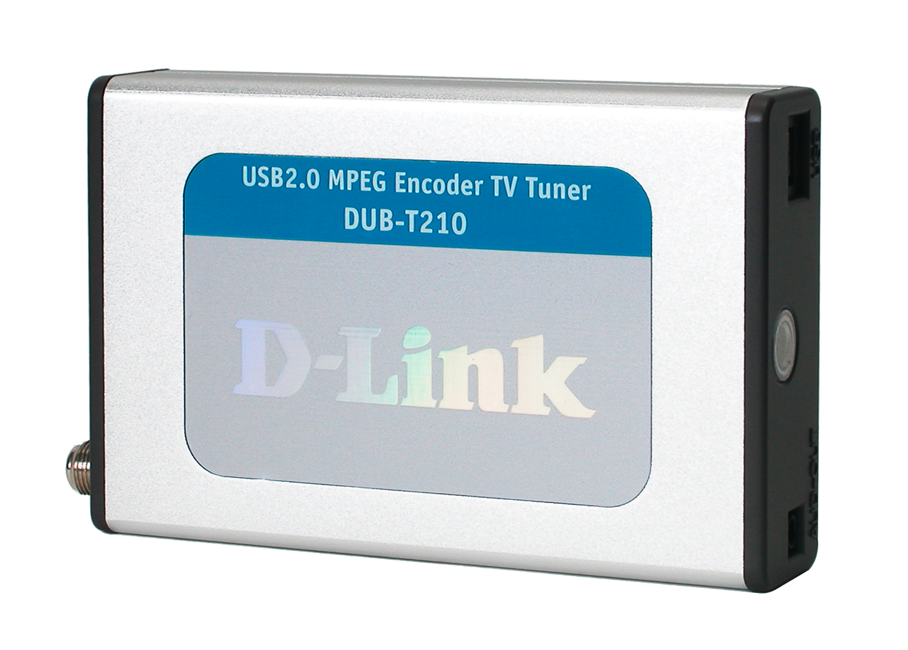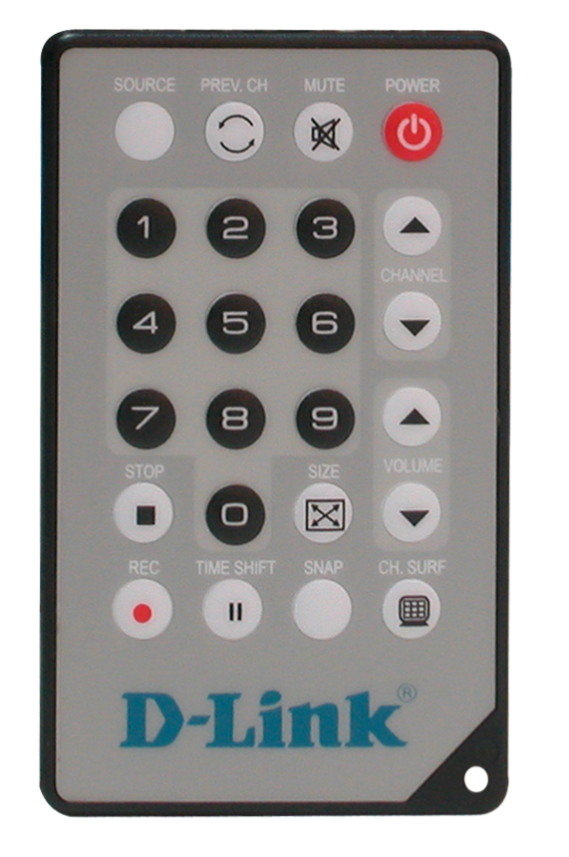
Why Sell This Product: | - Great add-on product for PC: this device allows users to watch TV from their PC and record TV programs to hard disk & CD/DVD.  - Great add-on product for analog video cameras, VHS recorders.  - The DUB-T210 is a replacement product for the DUB-T200, which has been phased out. Comparing with the DUB-T200, the DUB-T210 is cheaper in cost and much smaller in size, supports more conversion formats, and includes a remote control for TV program selection, function operation and configuration through the TV screen (with the old DUB-T200, you had to do all these through the computer keyboard). Both products provide analog-to-digital format conversion by software. Our next-generation product will provide analog-to-digital conversion by hardware.  Selling Points  - Lower cost.  - Compact size with remote control included.  - All necessary software (format conversion software, editing software, CD/DVD burner) included free of charge.  - PAL and NTSC formats supported.
Key Features: | - Full TV tuner functions: CATV, VHF, UHF  - Real time or pre-scheduled TV program recording and playback  - Full-channel/auto-scan function  - Time shift function, multi-channel TV sound (MTS) support  - DVD resolution quality: 720 x 480 @ 30fps (NTSC), 720 x 576 @25fps (PAL)  - SVCD resolution quality: 480 x 480 @ 30fps (NTSC), 480 x 576 @25fps (PAL)  - VCD resolution quality: 352 x 240 @ 30fps (NTSC), 352 x 288 @25fps (PAL)  - Snap shot: 720 x 480 still image  - Video bit rate: up to 10Mbps  - Audio bit rate: 8Kps to 48Kbps  - Audio capture with audio/video synchronization function  - Capturing and recording standard formats: AVI, MPEG1,MPEG2, MPEG4  - Saturation, contrast, hue, brightness adjustment  - Direct burn-to-disc of recorded MPEG1/2 with VCD, SVCD &DVD quality  - MPEG movie creation with video editing software included  - USB 2.0 interface to PC  - Slim, compact remote control included
Technical Details: | System Requirements  - CPU 1.2 GHz or above (CPU 2.4GHz or above is required for real-time recording)  - Microsoft Windows 2000 SP4 or XP  - Microsoft-DirectX 8.1 or above  - Minimum 256MB RAM  - CD-ROM, CD-R/RW, DVD+R/RW, DVD-R/RW  - 16-bit or better sound card  - One available USB 2.0 port  - PCI/AGP VGA card with minimum 64MB RAM  Output to PC  USB 2.0  Input From CATV  Coaxial connector  Input From Analog Camcorder, VCR, DVD  - S-Video (S-Terminal)  - RCA jacks (3 RCA jacks: 2 for audio, 1 for video)  TV  - NTSC and PAL support  - Time-shift function  - MTS (Multi-channel TV Sound) support  - Automatic channel configuration  - Automatic recording through advanced scheduling  Data Compression & Recording  - Real-time MPEG1, MPEG2, MPEG4 recording and playback  - Background recording when PC is in use  - Video CD compliant  - Compression ratio and image quality control through software  Screen Display  Full-screen or TV in a window  Physical & Environmental  Power Input  Powered directly from USB bus, no external power adapter required  Dimensions  111 (L) x 70 (W) x 22 (H) mm (device only)  Weight  168.6 grams (device only, without remote control)  Operating Temperature  0 to 55 ℃  Storage Temperature  -35 to 75 ℃  Operating Humidity  10% to 90% non-condensing  Emission  - FCC Class B  - CE  - C-Tick  Software & O.S. Driver Support  - TV Plus, MPEG Editor, DVD Maker software (included)  - Microsoft Windows 2000 (SP4), XP  Package Includes  - DUB-T210 MPEG Encoder/TV Tuner  - USB 2.0 cable  - Audio/video cable  - S-Video to RCA converter  - Audio cable (for Windows 2000 only)  - Remote control  - CD (includes software and driver programs, User's Manual)  - Printed Quick Installation Guide
EMI/EMC Report | ☑FCC No 04LE397FB ☑ CE No 04LE397C ◻ VCCI No.  ◻ CTR-21 No. ☑ C-Tick No. ◻ A-Tick No.  ◻ FDA No. ◻ R&TTE No. ◻ BSMI No.  ◻ Others
Safety | ◻ TUV No. ◻ UL No. ◻ CSA No.  ◻ Others
Packaging Style | ◻ Clamshell ◻ White Box ☑ Gift Box ◻ Bulk ◻ White Box with D-Link Logo  ◻ Others
Packaging Contents: | DUB-T210 * 1  USB2.0 Cable *1  AV Cable * 1  S-Viideo to RCA Converter *1  Audio Cable( For Windows2000 Only) *1  Remote controller * 1  CD* 1  QIG* 1
UPC Code:
  IUBT210…A1 | 790069 | 272974
  IUBT210P..A1 | 790069 | 272981
  NUBT210P..A1 | 790069 | 275739
  TUBT210...A1 | 790069 | 275746
Units Per Carton: | 20
Cartons Per Pallet: | For USA Air:24, Sea: 30 | For WW Air:24, Sea:30
Dimensions and Weight: | Box:  mm,Others , 0.691 kg  Carton: 464 x 388 x 323 mm, 16 kg  Pallet: (by Air) 1220 x 1020 x 1510 mm, 294 kg (for USA)  1200 x 1100 x 1510 mm, 294 kg (for WW)  (by Sea) 1220 x 1020 x 1850 mm, 363 kg (for USA)  1200 x 1100 x 1850 mm, 363 kg (for WW)  INTRASTAT weight : 0.296 kg (Box)  Packing material weight (Box):  - Paper: 0.2354 kg  - Plastic: 0.0034 kg  - Mixed: 0.0046 kg

PMA
Product Class
Item Group
Sub Group
Intelligence
Tech.(Features)
Layer
Application


Q'ty

Interface
Net Interface
Port NO.
Interface
Net Interface
Port NO.

